

**SAKURA HOSTEL MANAGEMENT SYSTEM**

**Software Requirement Specification**

– Ho Chi Minh City, June 2022 –

**Table of Contents**

1. Overview **5**
   1. Introduction 5
   2. System Functions 7
      1. Screen Flow 7
      2. Screen Details 7
      3. User authorization 8
      4. Non-screen functions 11
   3. Common requirements 11
2. Functional Requirements **12**
   1. Authentication 12
      1. Login by username and password 12
      2. Login by email 12
      3. Login by facebook 12
   2. Recover password 13
   3. Register 14
      1. Fill register form 14
      2. Register with gmail 14
      3. Register with facebook 14

4. Guest’s functions 14

View hostel list with paging 14

View hostels’ details 16

View landlord list with paging 17

View landlords’ details 17

5. Change user profile 18

6. Change password 18

7. Tenant’s functions 19

View hostel list with paging 19

View hostels’ details 19

View landlords’ details 21

View room list 21

View room’s detail 21

Write review of a hostel/room 22

View landlord’s announcement 22

Cancel renting 23

8. Payment 23

View invoice list 23

View monthly payment detail 24

10. Statistics for landlords 25

View general statistics of revenue, hostels, tenants 25

11. Hostel management for landlord 25

Add hostel 25

View hostel list with paging 26

View hostel’s detail 27

Edit hostel’s detail 28

Activate/deactivate a hostel 28

13. Room management for landlord 30

View room type list 30

Add room type 31

Edit room type 31

View room list with paging 32

Add a room 33

Remove a room 33

View room’s detail 33

Edit room’s detail 34

View service list 35

View service history 35

Add service 36

Edit service 37

14. Tenant management for landlord 37

View tenant list with paging 37

Approve a rental request 37

Add a tenant (bỏ) 37

Remove a tenant 37

View tenant’s detail 37

Edit tenant’s information 38

Send announcement to tenants 38

Post payment invoice 38

15. Revenue management for landlords 39

View revenue statistics of a specific hostel 39

Export to Excel file 39

16. Admin features 39

View landlord list with paging 39

Edit landlord’s information 39

Activate/Deactivate a landlord account 40

Approve a landlord’s request(bỏ) 40

View hostel list with paging 40

Edit hostel’s information 40

Activate/Deactivate a hostel 41

View tenant list with paging 41

Edit tenant’s information 42

Activate/Deactivate a tenant account 42

# Overview

## Introduction

The purpose of this document is to collect and analyse ideas that have come up to define the system, its requirements with respect to the customers. We hope this document will be used in order to have a better understanding of the project, outline concepts that can be developed in the future, ideas that are being considered, or discarded in the development process of the product

In short, the purpose of this document is to provide a detailed overview of the team’s product, along with its scope and goals. The document will describe the project's target audience, user interface, hardware and software requirements. This provides the readers with our sights about the product and its functionality. In addition, we hope the document will help any designers and developers to assist in the software development cycle (SDLC) of this project.

The Sakura Hostel Management System aims to be a convenient place for tenants and landlords to manage their rentals. With this system, landlords will be greatly assisted with various functionalities such as tenants and hostel managements, viewing statistics of revenue and hostel usage and so on. The system provides landlords with the ability to interact with their tenants fast and conveniently, including sending and receiving requests, and posting payment information. On the other hand, tenants can quickly search for suitable rent using the smart filtering function of the system. Communication with landlords will be much more interactive through the various functions of the system including sending requests and viewing announcements.

More specifically, this system is designed to help people who want to find a hostel by using filters about cost, review score,... Then, they can see the hostel’s details like address, services, rooms, landlord’s details, as well as room’s details such as area, room number, monthly price, etc. After that, they can contact the landlord through phone numbers or email to see the hostel with their own eyes. If they are willing to choose that hostel to stay, the landlord will add them into their tenant management system, which will be described later.

The tenant management system will help the landlord to quickly manage the tenants that stay in their hostels. In a hostel, they can view the room members and their basic information such as date of birth, fullname, phone number, as well as sending notifications such as repair schedule or monthly invoice to them. Landlords can also accept a cancel renting request of tenants in case they want to move to somewhere else.

Moreover, landlords also have a hostel management system, in which they will be able to manage their hostel using the website. They can request the administrator to add a hostel, or to activate/deactivate it. In a hostel, they can add or edit a room, services and their cost. Landlords can also send a monthly invoice to tenants who stay at their hostel, and export the monthly invoice to files. Along with those functions, landlords can see the information chart about hostel monthly price, service costs, etc.

The main users of the systems are tenants and landlords within the area of Ho Chi Minh City and Ha Noi capital.

The system will be developed with Java programming language, making use of the JSP and Servlet technologies and MVC2 architecture and AJAX technologies. The system is expected to operate well on Chrome browser.

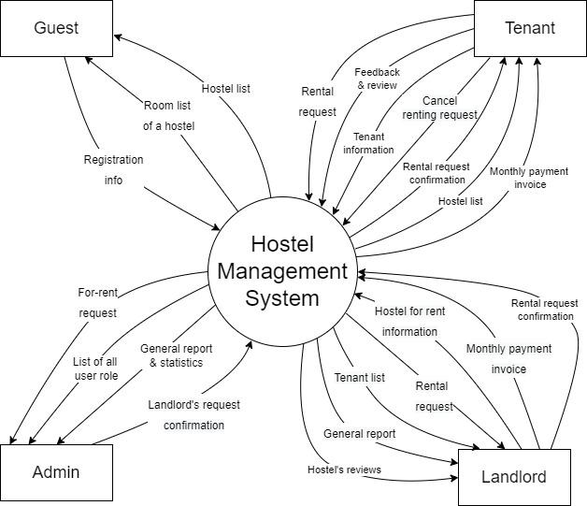

## System Functions

### Screen Flow

### Screen Details

| **#** | **Feature** | **Screen** | **Description** |
| --- | --- | --- | --- |
|  | Authorization | Login | Authenticate user to give him/her access to authorised features |
|  | Authorization | Register | A guest can register to be a tenant or landlord |
|  | Authentication | Forgot password | Send OTP via email, phone to confirm request and authentication, after that let users reset their password |
|  | Guests’ feature | Home | A guest can browse hostel list and landlord’s detail |
|  | Manage user information | User profile | Users can view and edit their personal information |
|  | Manage user information | Change password | User can change their account password |
|  | Tenants’ feature | Tenant page | A tenant can view hostel list, landlord list / manage his rental room |
|  | Tenants’ feature | Announcement | Tenant can view announcement from admin or landlord |
|  | Tenants’ feature | Cancel renting | Tenant can send a cancel renting form to landlord |
|  | Landlords’ feature | Landlord page | Landlord can see the overview information about his/her hostels and register a new one |
|  | Hostel management | Hostel list | Landlord can view a hostel list |
|  | Add a hostel for rent | Add hostels for rent | Landlord can add hostel and post it to the website |
|  | Hostel management | Overview | Landlord can see overview information of the hostel |
|  | Room management | Room list | Landlord can view the room list of a hostel |
|  | Manage room residents | Room residents list | Landlord can view the tenant list who stay at the hostel |
|  | Manage revenue | Revenue | Landlord can see the bill, revenue number and chart of the hostel |
|  | General report | Admin dashboard | Admin can receive and answer report from users through system notifications |
|  | Landlord management | Landlord management | Admin can view a list of landlords and see their personal information and their hostel |
|  | Hostel management | Hostel management | Admin can view a list of hostels and see their information |
| 22 | Tenant management | Tenant management | Admin can view a list of tenant and see their personal information |
| 23 | Notification management | Notification management | Tenant, landlord and admin can view notifications that are sent from the system |

### 

### User authorization

| **Screen** | **Tenant** | **Landlord** | **Admin** | **Guest** |
| --- | --- | --- | --- | --- |
| Login | X | X | X | X |
| 1. Login by username, password | X | X | X | X |
| 1. Login by gmail | X | X | X | X |
| 1. Login by facebook | X | X | X | X |
| Recover password | X | X | X |  |
| 1. Reset password | X | X | X |  |
| Register | X | X | X | X |
| 1. Fill register form | X | X | X | X |
| 1. Register with gmail | X | X | X | X |
| 1. Register with facebook | X | X | X | X |
| Home | X | X | X | X |
| 1. View hostel list with paging | X | X | X | X |
| 1. View hostel’s detail | X | X | X | X |
| 1. View landlord list with paging | X | X | X | X |
| 1. View landlord’s detail | X | X | X | X |
| 1. Bookmark hostel | X |  |  |  |
| User profile | X | X | X |  |
| 1. Change user profile | X | X | X |  |
| Change password | X | X | X |  |
| 1. Change password | X | X | X |  |
| Tenant page | X |  |  |  |
| 1. View hostel list with paging | X |  |  |  |
| 1. View hostel’s detail | X |  |  |  |
| 1. View landlord list with paging | X |  |  |  |
| 1. View landlord’s detail | X |  |  |  |
| 1. View booking requests | X |  |  |  |
| 1. View landlord’s invitation to stay at a hostel | X |  |  |  |
| 1. View room’s detail | X |  |  |  |
| 1. Write review of a hostel | X |  |  |  |
| 1. Edit a review of a hostel |  |  |  |  |
| 1. Send rental request | X |  |  |  |
| 1. View announcement | X |  |  |  |
| 1. Cancel renting | X |  |  |  |
| Payment invoice | X |  |  |  |
| 1. View monthly payment detail | X |  |  |  |
| Landlord page |  | X |  |  |
| 1. View general statistics of revenue, hostels, tenants |  | X |  |  |
| Hostel list |  | X |  |  |
| 1. Add hostel |  | X |  |  |
| 1. View hostel list with paging |  | X |  |  |
| 1. View hostel’s detail |  | X |  |  |
| 1. Edit hostel’s detail |  | X |  |  |
| 1. Activate/Deactivate a hostel |  | X |  |  |
| 1. Add hostel’s services |  | X |  |  |
| 1. Edit services detail |  | X |  |  |
| 1. Remove hostel’s services |  | X |  |  |
| Overview |  | X |  |  |
| 1. View general report of a specific hostel |  | X |  |  |
| 1. View booking request list |  | X |  |  |
| 1. Approve/Refuse booking request |  | X |  |  |
| Room type |  | X |  |  |
| 1. Add room type |  | X |  |  |
| 1. Edit room type |  | X |  |  |
| 1. View room list with paging |  | X |  |  |
| 1. Add a room |  | X |  |  |
| 1. Remove a room |  | X |  |  |
| 1. View room’s detail |  | X |  |  |
| 1. Edit room’s detail |  | X |  |  |
| Room resident list |  | X |  |  |
| 1. View room resident list with paging |  | X |  |  |
| 1. Approve a rental request |  | X |  |  |
| 1. Add a room resident |  | X |  |  |
| 1. Remove a room resident |  | X |  |  |
| 1. View room resident’s detail |  | X |  |  |
| 1. Edit room resident’s information |  | X |  |  |
| 1. Post payment invoice |  | X |  |  |
| Revenue |  | X |  |  |
| 1. View revenue statistics of a specific hostel |  | X |  |  |
| 1. Export report to excel file |  | X |  |  |
| Admin |  |  | X |  |
| 1. View landlord list |  |  | X |  |
| 1. Edit landlord’s information |  |  | X |  |
| 1. Activate/Deactivate a landlord account |  |  | X |  |
| 1. View hostel list |  |  | X |  |
| 1. Edit hostel’s information |  |  | X |  |
| 1. Activate/Deactivate a hostel |  |  | X |  |
| 1. View tenant list |  |  | X |  |
| 1. Edit tenant’s information |  |  | X |  |
| 1. Activate/Deactivate a tenant account |  |  | X |  |

In which:

* **Tenant:** Tenants can add, update or delete their personal information. They can make requests to rent a hostel and make payments for their rent. They can also send requests, recommendations to the landlords.
* **Landlord:** Landlords can manage the hostels they own, including adding, deleting, updating information about the hostels. They can also post payment information and see the statistics about the revenue and usage of the hostels.
* **Admin:** Admins can manage the lists of landlords, tenants and hostels. They can add, delete, modify the details related to each group of data.
* **Guest:** A guest is a non-registered user who can search for hostels based on various criteria.

### Non-screen functions

|  |  |  |  |
| --- | --- | --- | --- |
| **#** | **Feature** | **System Function** | **Description** |
| 1 | Authentication | Reset password | Send new random password to user via provided email to authentication |
| 2 | Authorization | Logout | End user’s login session and return him/her to homepage |
| 3 | Notification management | Send notification | When users interact with some function in system, it will automatically send a notification back to user |
| 4 | Statistic | Export invoice to excel file | User chooses an invoice and export its information to excel file |
| 5 | Tenant page | Send booking request | After tenant clicked the booking request button in room detail page, system will send a booking request to the landlord |
| 6 | Tenant page | Accept/refuse landlord’s renting invitation | After landlord approved booking request, tenant can choose between accepting or refusing landlord’s renting invitation |

## Common requirements

* The language used in website is Vietnamese.
* Password of the user is encrypted with SHA-1 algorithm.

# Functional Requirements

## Authentication

### Login by username and password

* Trigger: clicking on “Sign in with password” button on homepage
* Description*:* Users sign in to the system using the existing profile
* Layout: Mock-up prototype for screen, the sample is the picture below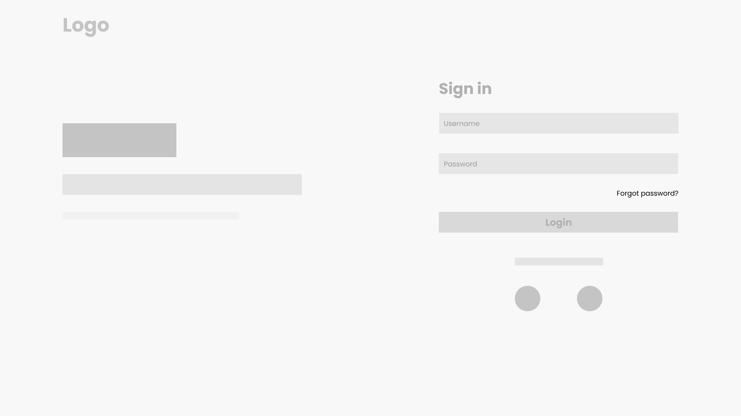
* Details: The username and password pair is checked if they match those of an existing user in the database. If yes, the user is logged in. If not, a warning is sent to the browser.

### Login by email

* Trigger: clicking on “Sign in with email” button on homepage
* Description: User signs in with a connected email
* Details: The system checks if the email is registered in the database. If yes, the user is logged in. If not, a warning message is sent to the browser
* Layout: None

### Login by facebook

* Trigger: clicking on “Sign in with Facebook” button on homepage
* Description: User signs in with a connected Facebook account
* Details: The system checks if the facebook account is registered in the database. If yes, the user is logged in. If not, a warning message is sent to the browser.
* Layout: None

## Recover password

* Trigger: clicking on “Recover password” button
* Description: user resets their password in case they forget the current password. Users must provide a username or the email address they used to register.
* Layout:

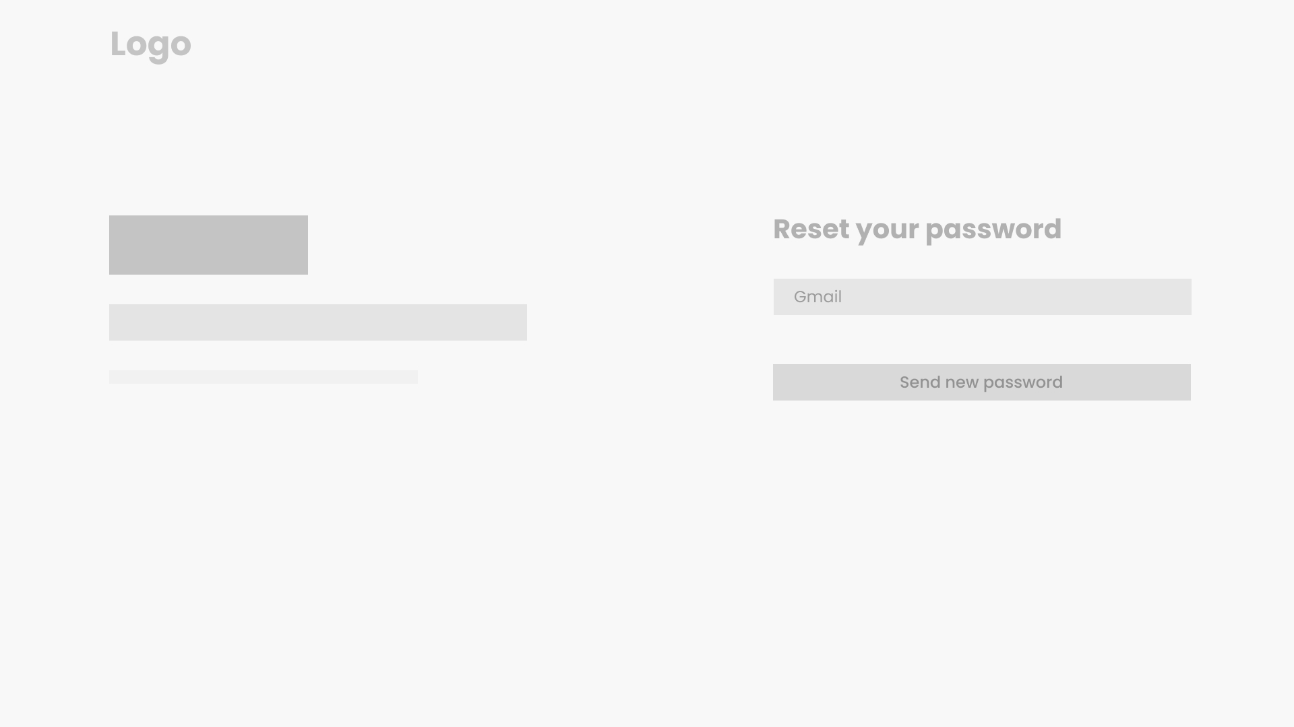

* Details: An email with a password reset link is sent to the email address used for registration. User follows the link, fill in their new password and click on the “Reset password” button

## Register

### Fill register form

* Trigger: Click on “Register button” button
* Description: User can register an account to login to the website using username and password
* Layout: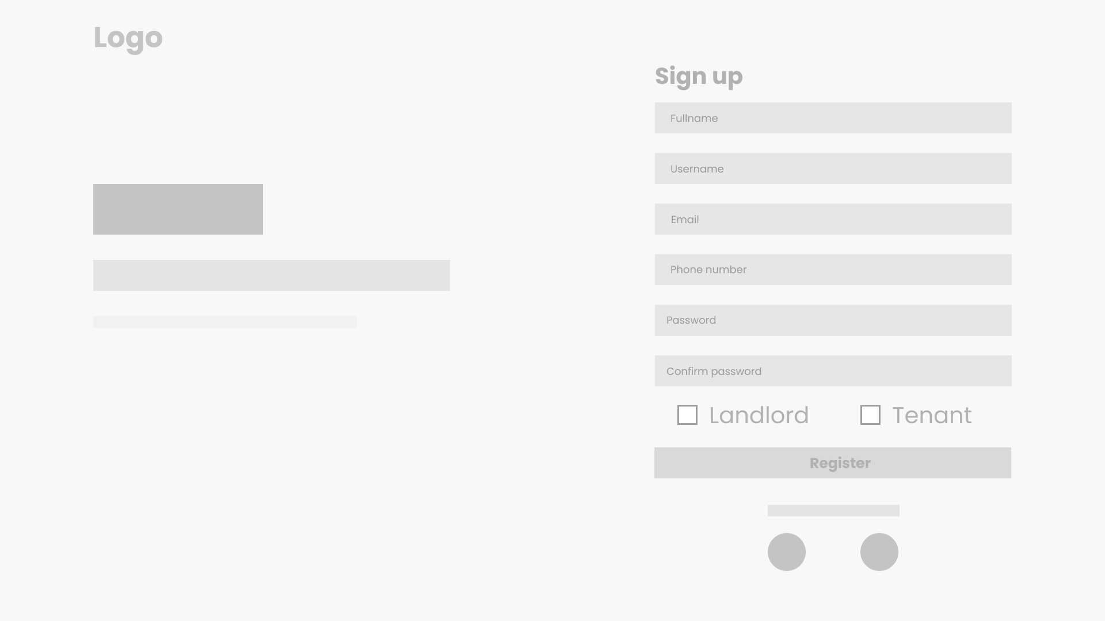
* Details: User need to fill a form that contain some basic information such as username, password, full name, email, phone number and their role as landlord or tenant

### Register with gmail

* Trigger: clicking on “Register with Gmail” button
* Description: User can use a gmail account to register an account
* Details: A screen will pop up when the user clicks on the “Register with Gmail” button and ask them to choose a gmail account and login. After their confirmation, the system will automatically register a new account using that gmail.
* Layout: None

### Register with facebook

* Trigger: Click on “Register with facebook” button
* Description: User can use a facebook account to register an account
* Details: A screen will pop up when the user clicks on the “Register with Facebook” button and ask them to choose a facebook account and login. After their confirmation, the system will automatically register a new account using that facebook account.
* Layout: None

## Guest’s functions

### View hostel list with paging

* Trigger: When the guest visit the website
* Description: Guests can view many hostels on the website, with a fixed amount per page.
* Details: Guests can see a list of hostels in many pages, and they also can filter hostels by provinces, districts, wards, and sort by price/rating. In addition, guests can search for a hostel by name.
* 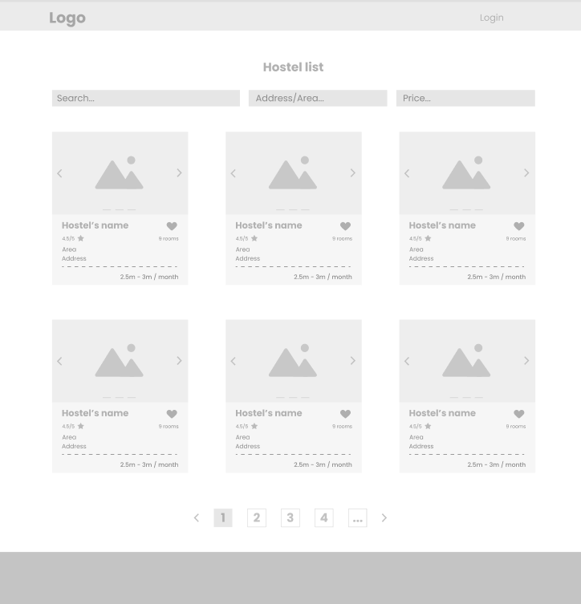

### View hostels’ details

* Trigger: When the guest click a hostel in a hostel list
* Description: Users can view detailed information about the hostel as well as the hostel's landlord information.
* Details: User will see information about the hostel such as address, services, name, images, rating, room cost. They can view a list of rooms, which will have a status as available/ near available / not available, as well as policy and location of the hostel on the map. Besides, the landlord's information such as name, phone number will also be displayed too.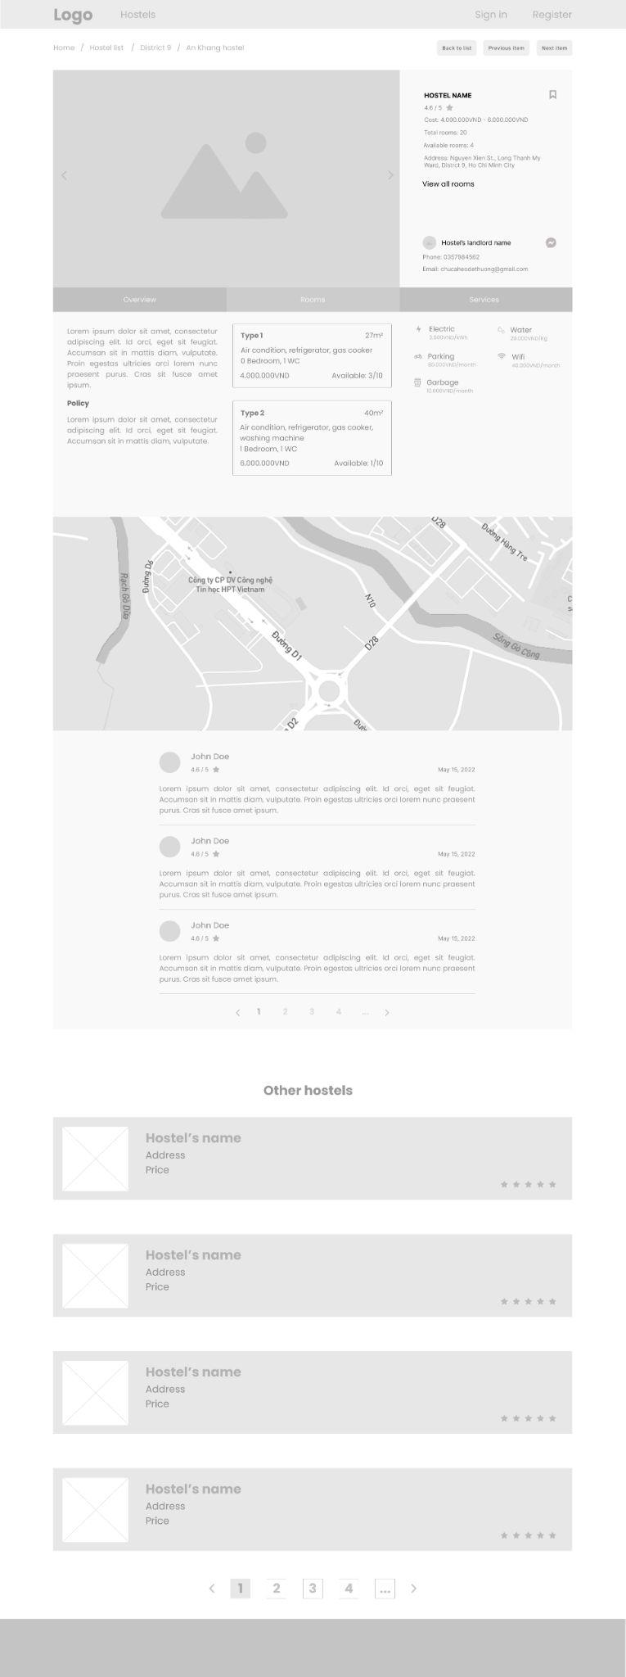
* Layout:



### View landlords’ details

* Trigger: When a user clicks on a landlord in the landlord list.
* Description: Users can see detailed information about a landlord
* Details: Detailed information about the landlord is his/her name, phone number, address, Facebook link, email address.
* Layout:

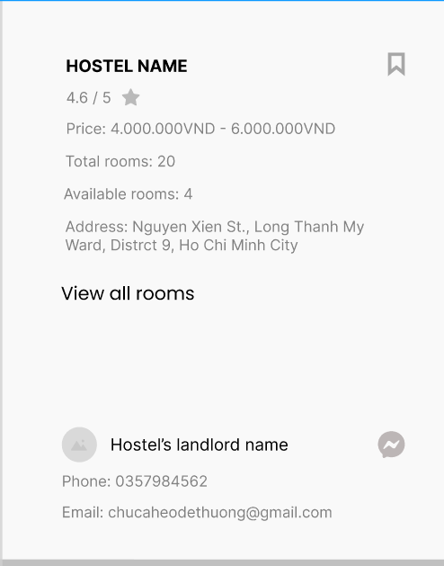

## Change user profile

* Trigger: When logged in user clicks on the profile button on the screen, and chooses the view profile option.
* Description: Users can view their profile as well as change some details.
* Details: Users can change information such as full name, phone number, date of birth, facebook link, and save their change immediately.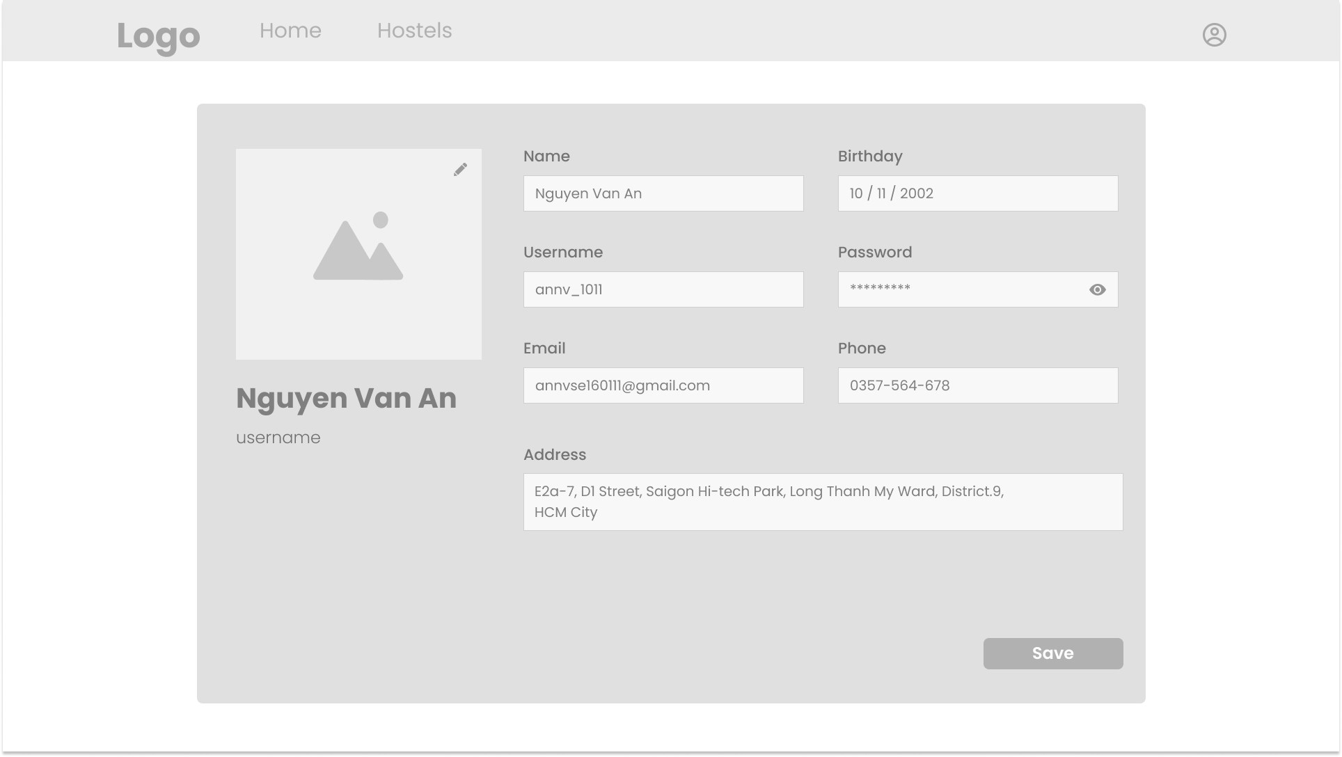
* Layout:

## Change password

* Trigger: When the user clicks on the profile button on the screen, and chooses the change password option
* Description: User can change their password
* Details: Users must enter the old password in order to change it to a new one. The new password must be confirmed twice.
* Layout:

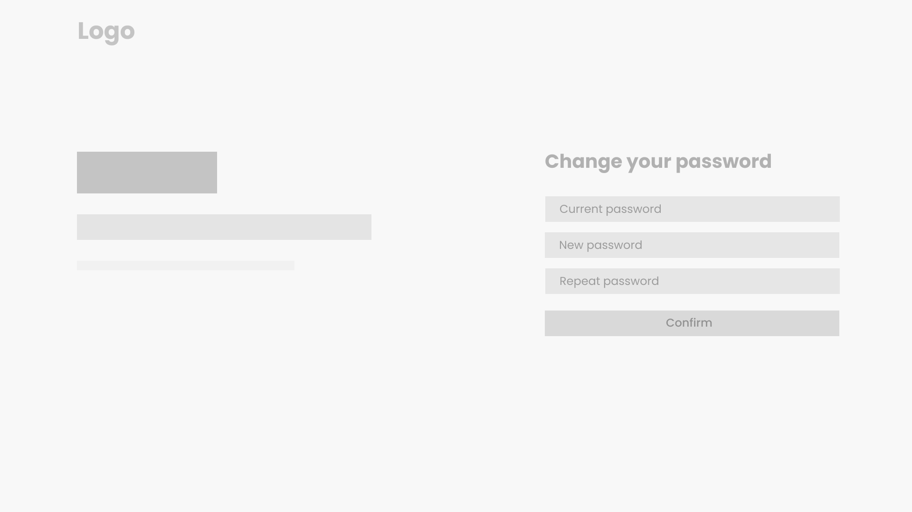

## Tenant’s functions

### View hostel list with paging

* Trigger: When the admin clicks on the landlord list button on the navigation bar.
* Description: The website will show a list of landlords
* Details: Landlords will be shown as a list with paging, with names, status, phone number. Admin can filter the landlords by name, phone number, or sort by created date.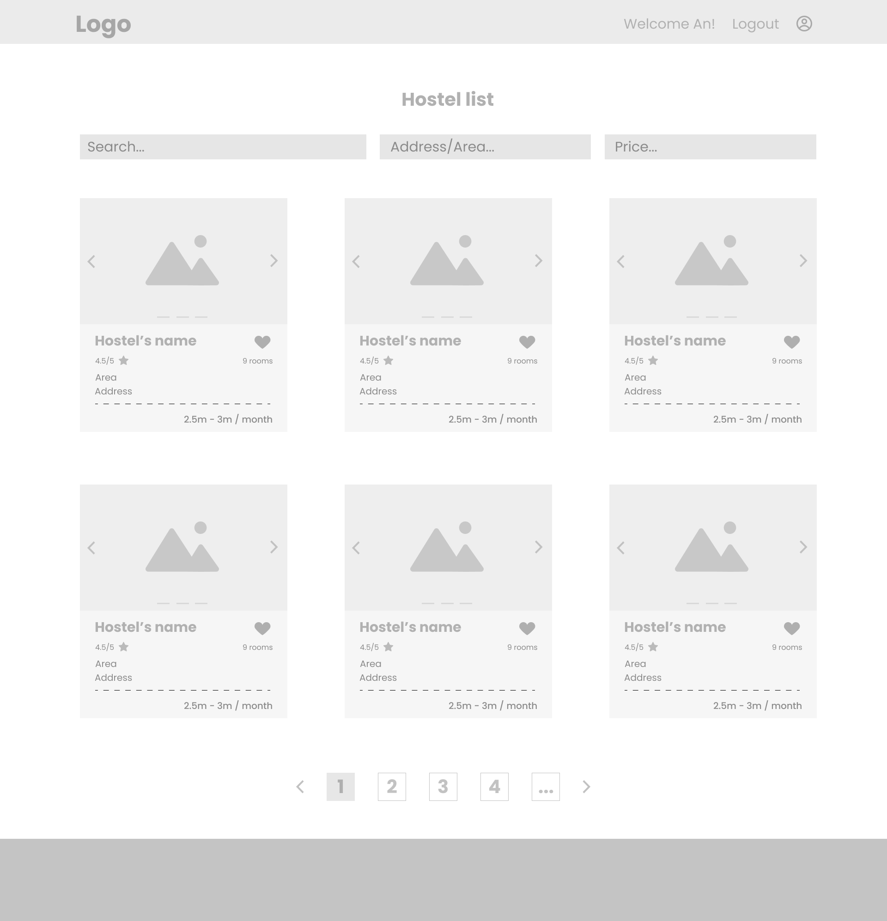
* Layout:

### View hostels’ details

* Trigger: When the user clicks a hostel in a hostel list
* Description: Users can view detailed information about the hostel as well as the hostel's landlord information.
* Details: User will see information about the hostel such as address, services, name, images, rating, room cost. They can view a list of rooms, which will have a status as available/ near available / not available, as well as policy and location of the hostel on the map. Beside, the landlord's information such as name, phone number will also be displayed too.
* Layout:

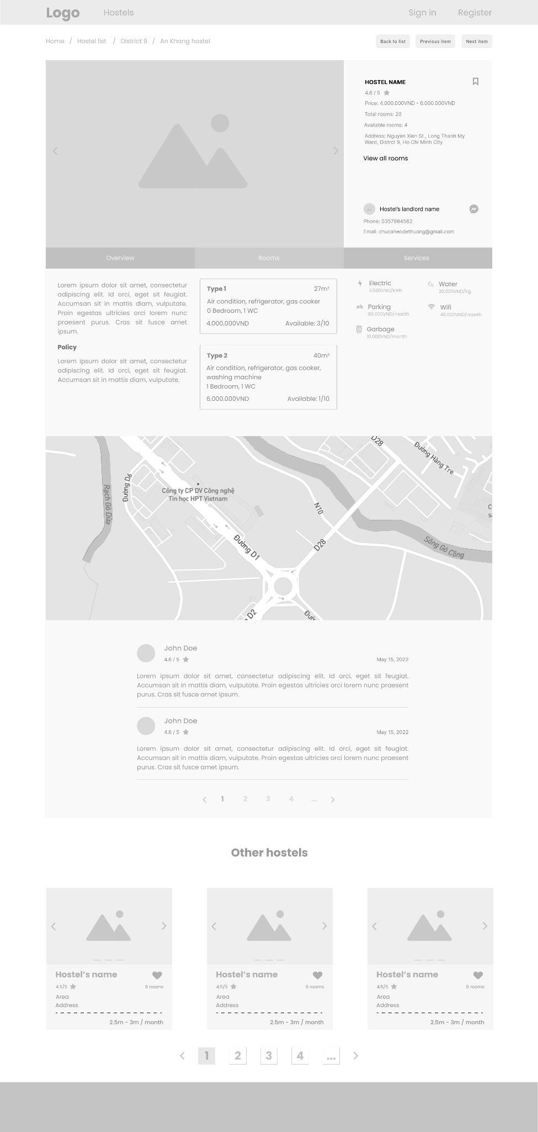

### View landlords’ details

* Trigger: When the user clicks a landlord in a hostel detail or landlord list
* Description: Users can view detailed information about the landlord
* Details: User will see information about the landlord such as name, phone number, email address, avatar
* Layout:
* 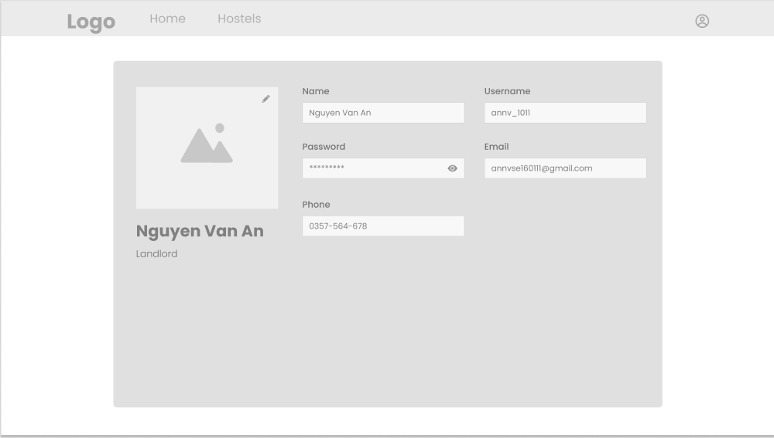

### View room list

* Trigger: When the user clicks a landlord in a hostel detail or landlord list
* Description: Users can view detailed information about the landlord
* Layout:

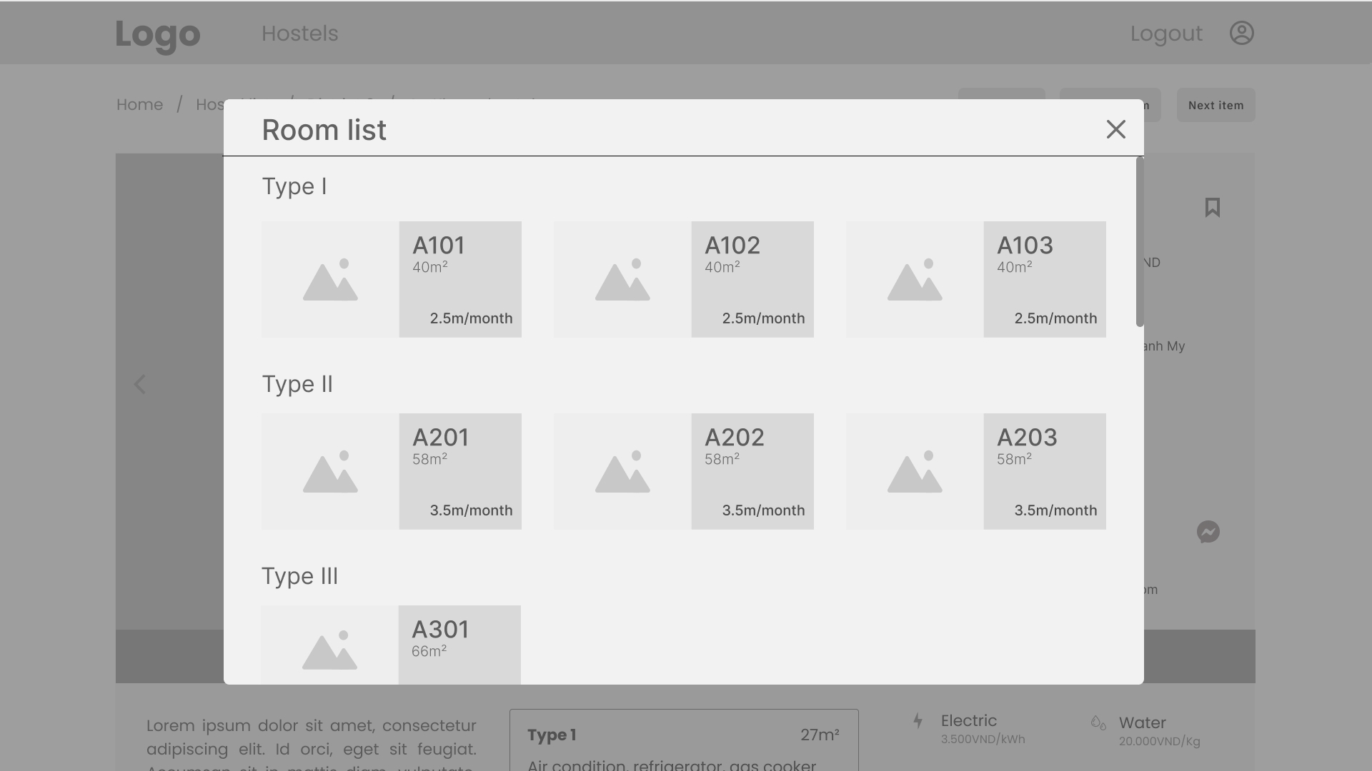

* Details: User will see information about the landlord such as name, phone number, email address, avatar

### View room’s detail

* Trigger: When the user click a landlord in a hostel detail or landlord list
* Description: Users can view detailed information about the landlord
* Details: User will see information about the landlord such as name, phone number, email address, avatar
* Layout:

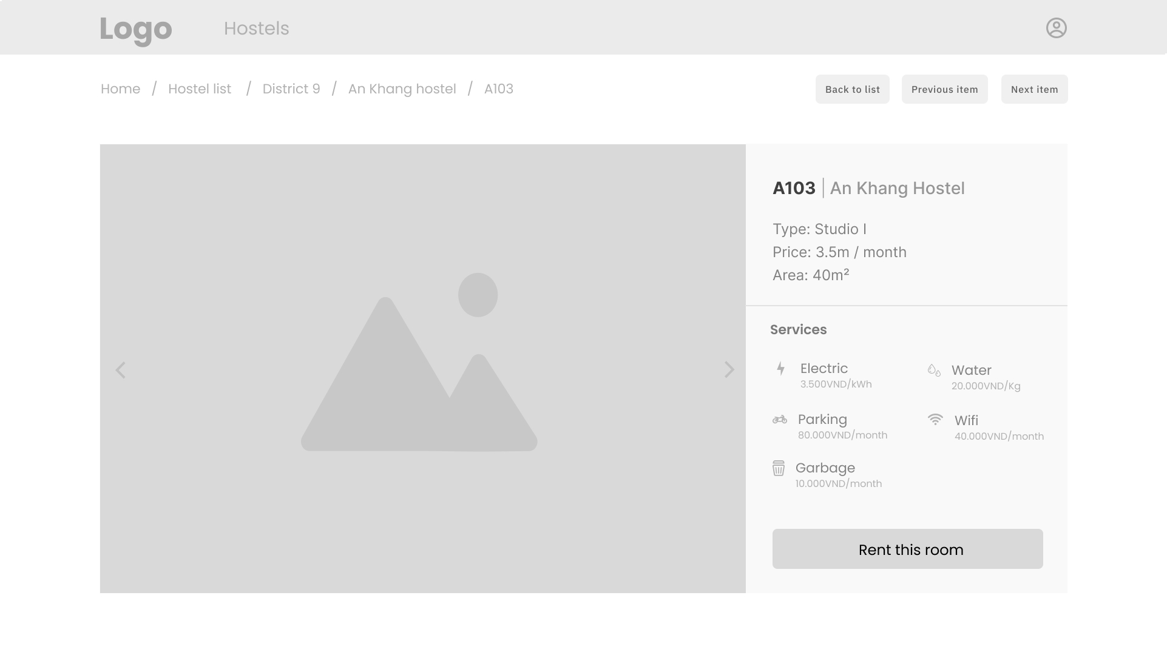

### Write review of a hostel/room

* Trigger: When the tenant click write feedback button of a hostel he/she rents
* Description: Tenants can write review about their current hostel
* Layout:

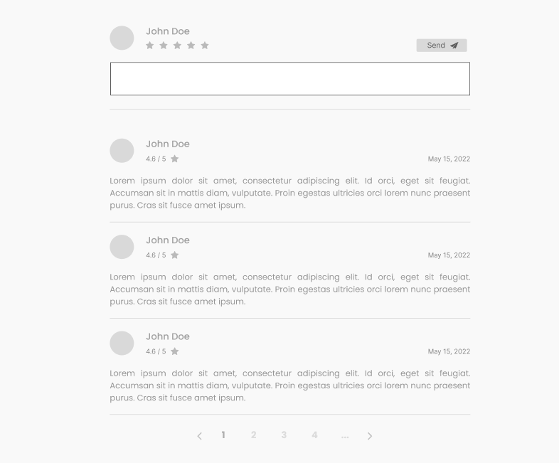

* Details: Tenants can write reviews about their current hostel, as well as giving rating stars. They can edit the review later

### View landlord’s announcement

* Trigger: When the tenant click notification button in tenant dashboard
* Description: Tenants can view messages of the landlord.
* Layout:
* Details: Tenants can view messages of the landlord, filtering them by date.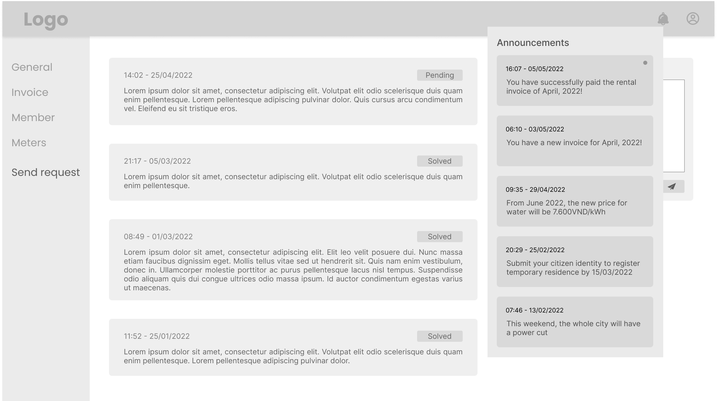

### Cancel renting

* Trigger: When the tenant click on the cancel button in tenant dashboard
* Description: Tenants can send a request to stop renting the current hostel
* Layout:

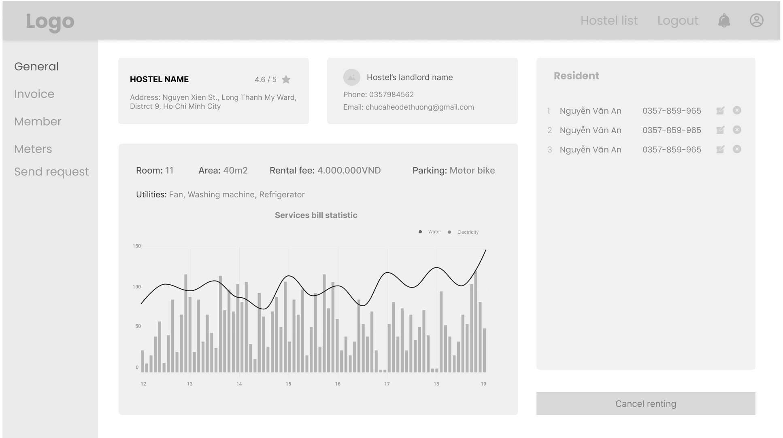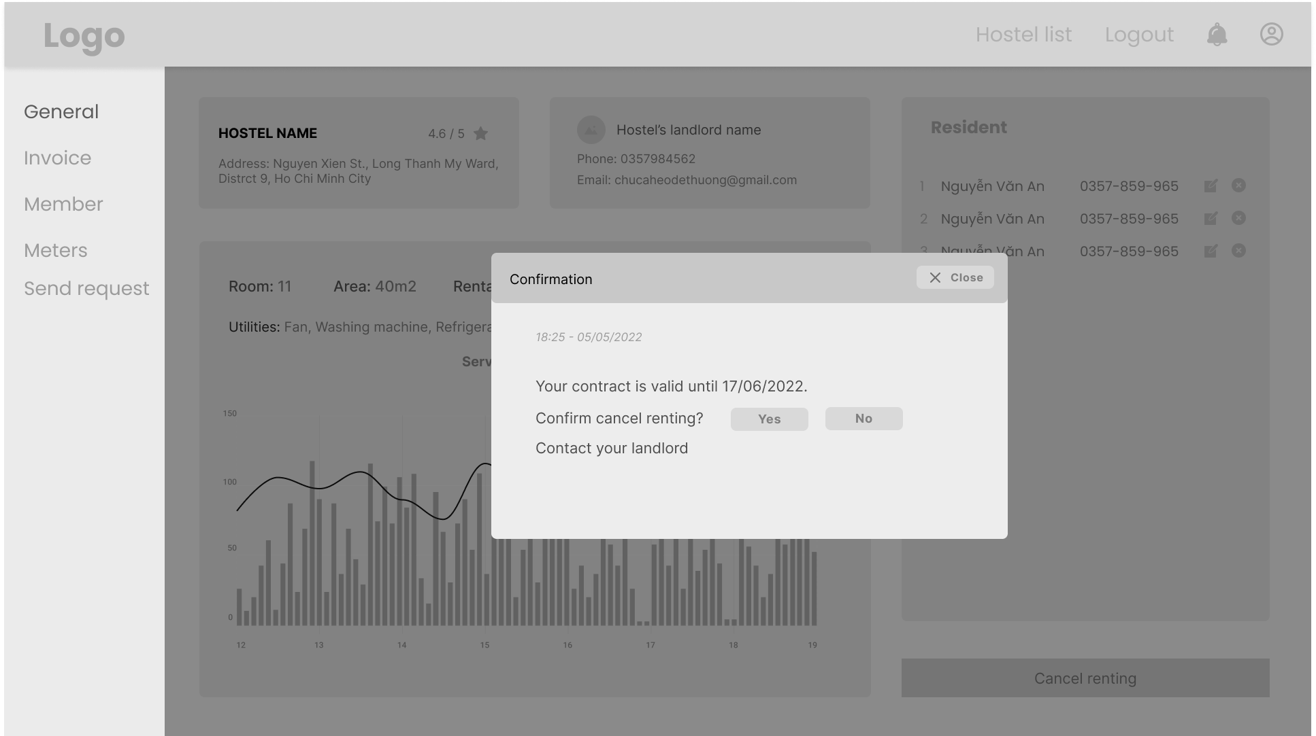

* Details: Tenants can send a request to stop renting the current hostel. After sending the request, they have to wait for the landlord to approve their cancellation request. When the landlord accepts their request, they will be free to rent other hostels.

## Payment

### View invoice list

* Trigger: When the tenant click invoice in the navigation bar
* Description: Tenants can view invoice history
* Layout:

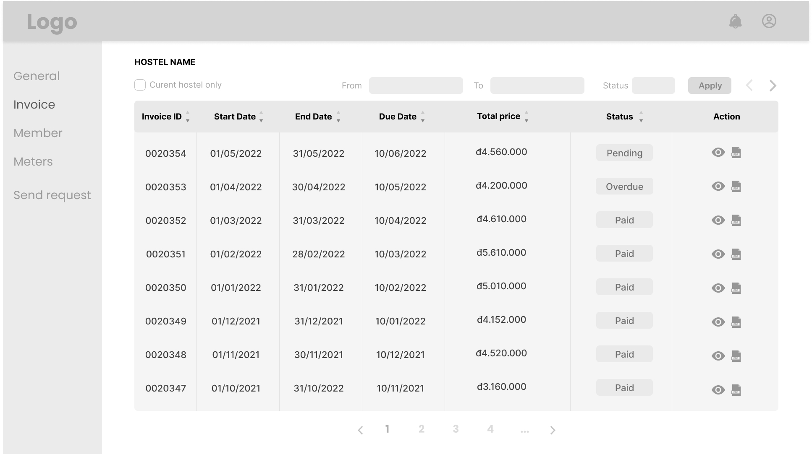

* Details: Tenants can view invoice information such as start date, end date, due date, total price, status

### View monthly payment detail

* Trigger: When the tenant click write feedback button of a hostel, he/she rents
* Description: Tenants can write review about their current hostel
* Layout:

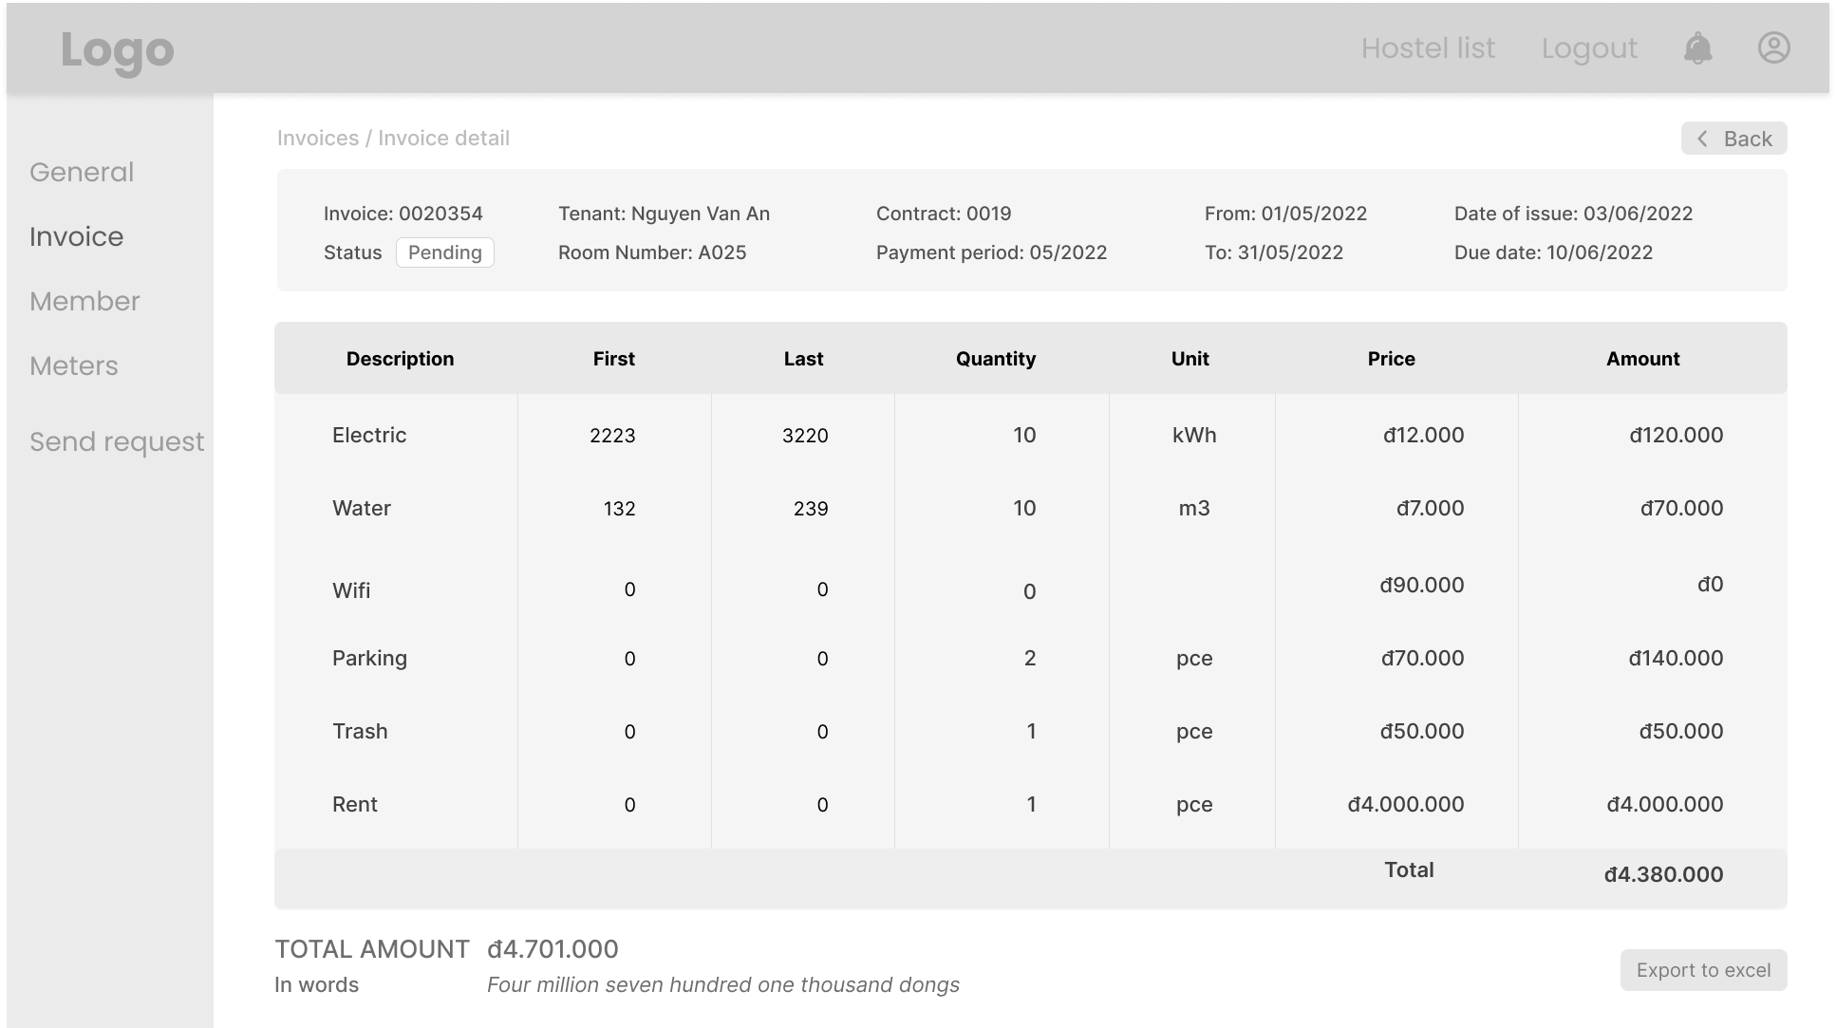

* Details: Tenants can write reviews about their current hostel, as well as giving rating stars. They can edit the review later

## Statistics for landlords

### View general statistics of revenue, hostels, tenants

* Trigger: When the landlord clicks statistics in landlord dashboard
* Description: Landlord can view a general statistic of revenue, hostels, tenants
* Layout:

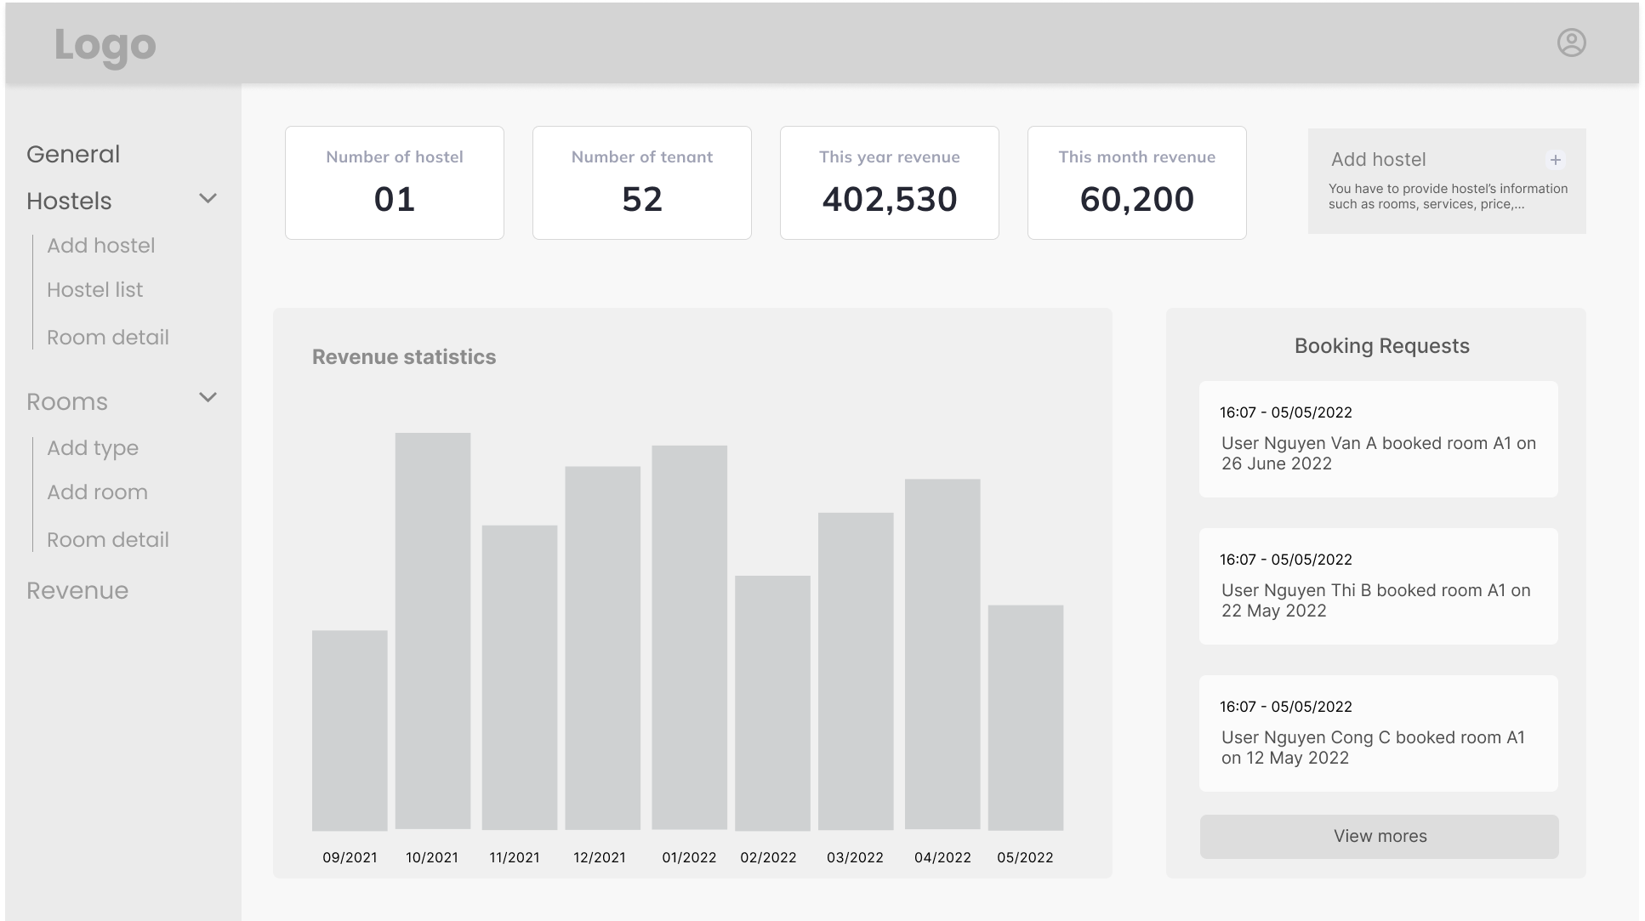

* Details: Landlords can view statistics, filter them by times (from month to month), and choose a specific hostel to view.

## Hostel management for landlord

### Add hostel

* Trigger: When the landlords click on add hostel on landlord dashboard
* Description: Landlords can add hostel to post it to the website
* Layout:

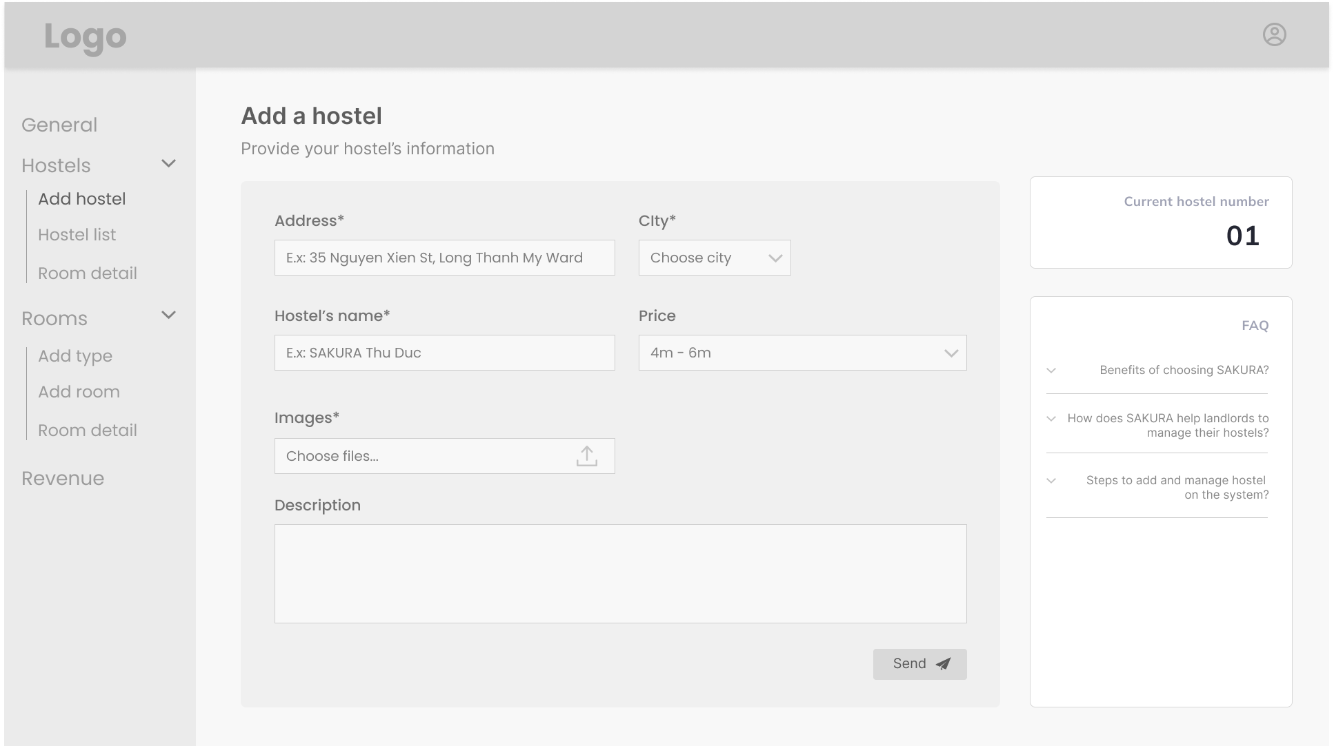

* Details: Landlords must fill information such as address, city, hostel name, price and images to add a hostel

### View hostel list with paging

* Trigger: When the landlords click on hostel list on landlord dashboard
* Description: Landlords can view their hostel in a list
* Layout:

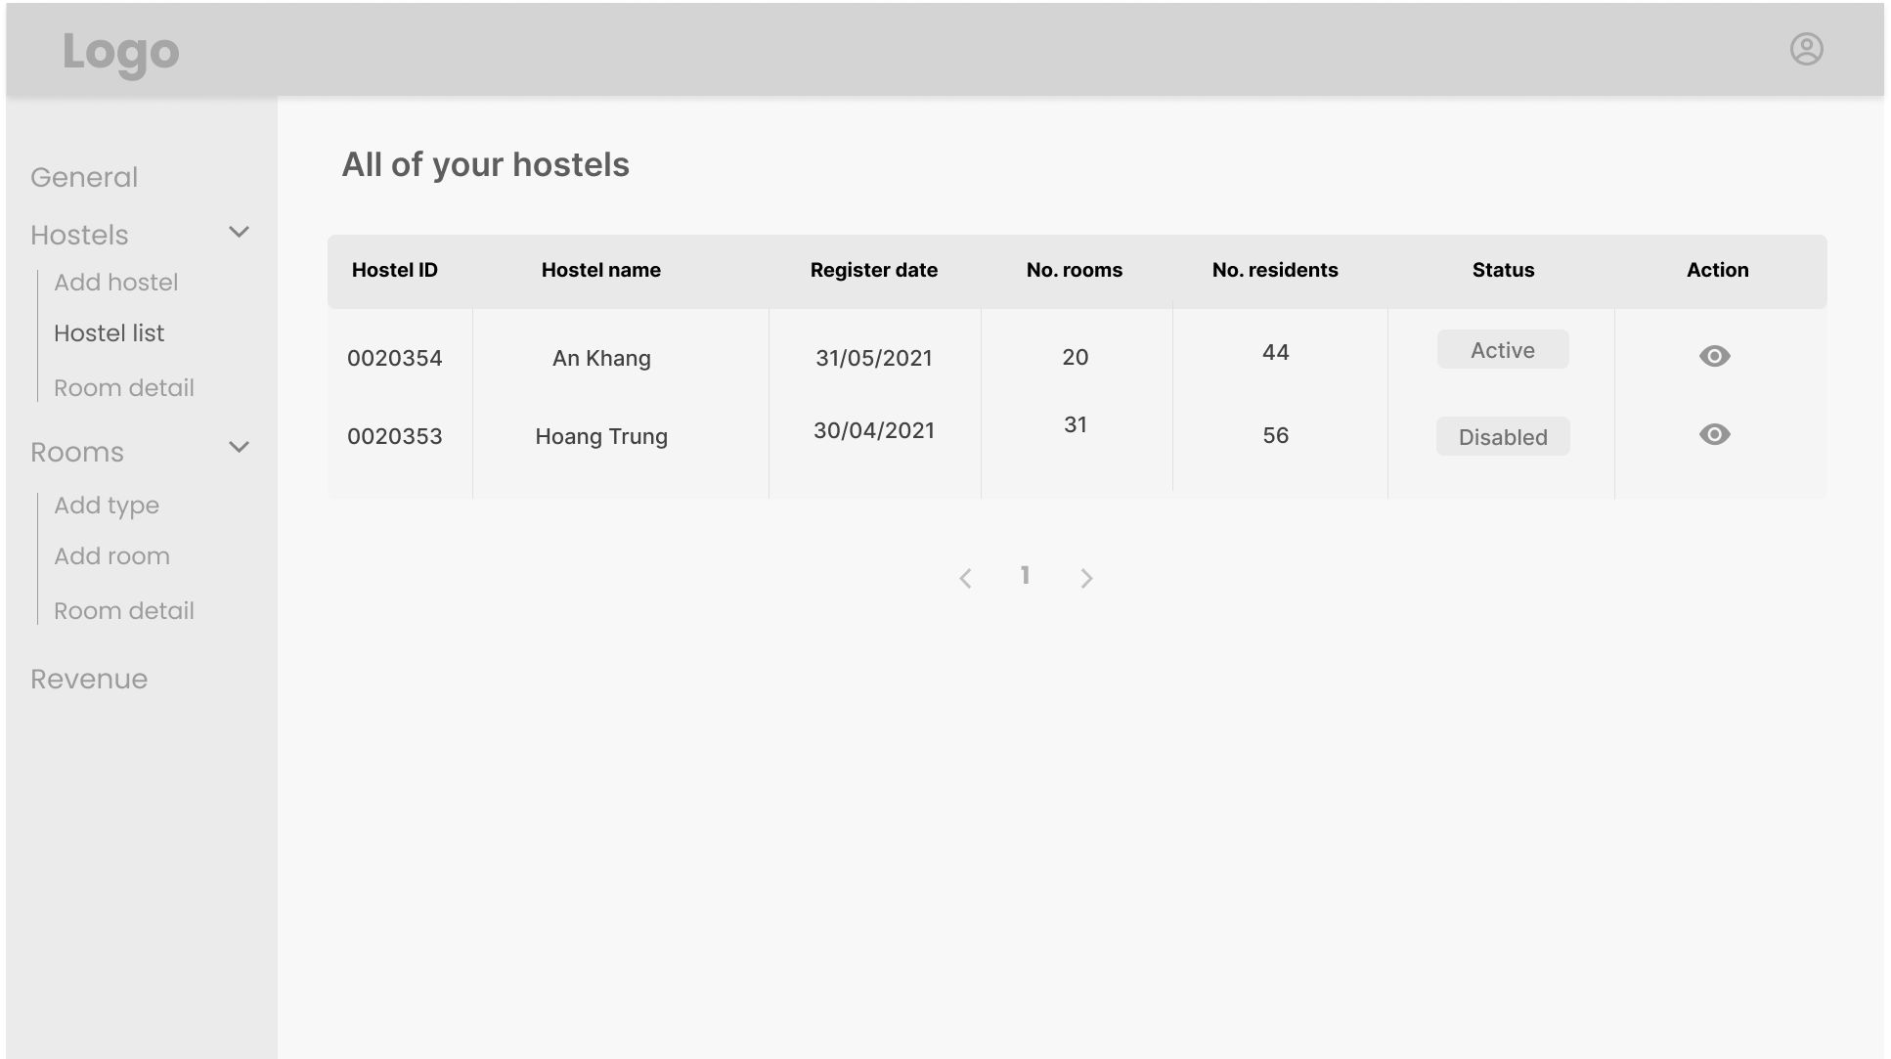

* Details: Landlords can view their hostel in a list with some basic information, and they can click on a hostel to view hostel detail

### View hostel’s detail

* Trigger: When the landlords click on a hostel in the hostel list
* Description: Landlord can view their hostels’ details
* Layout:

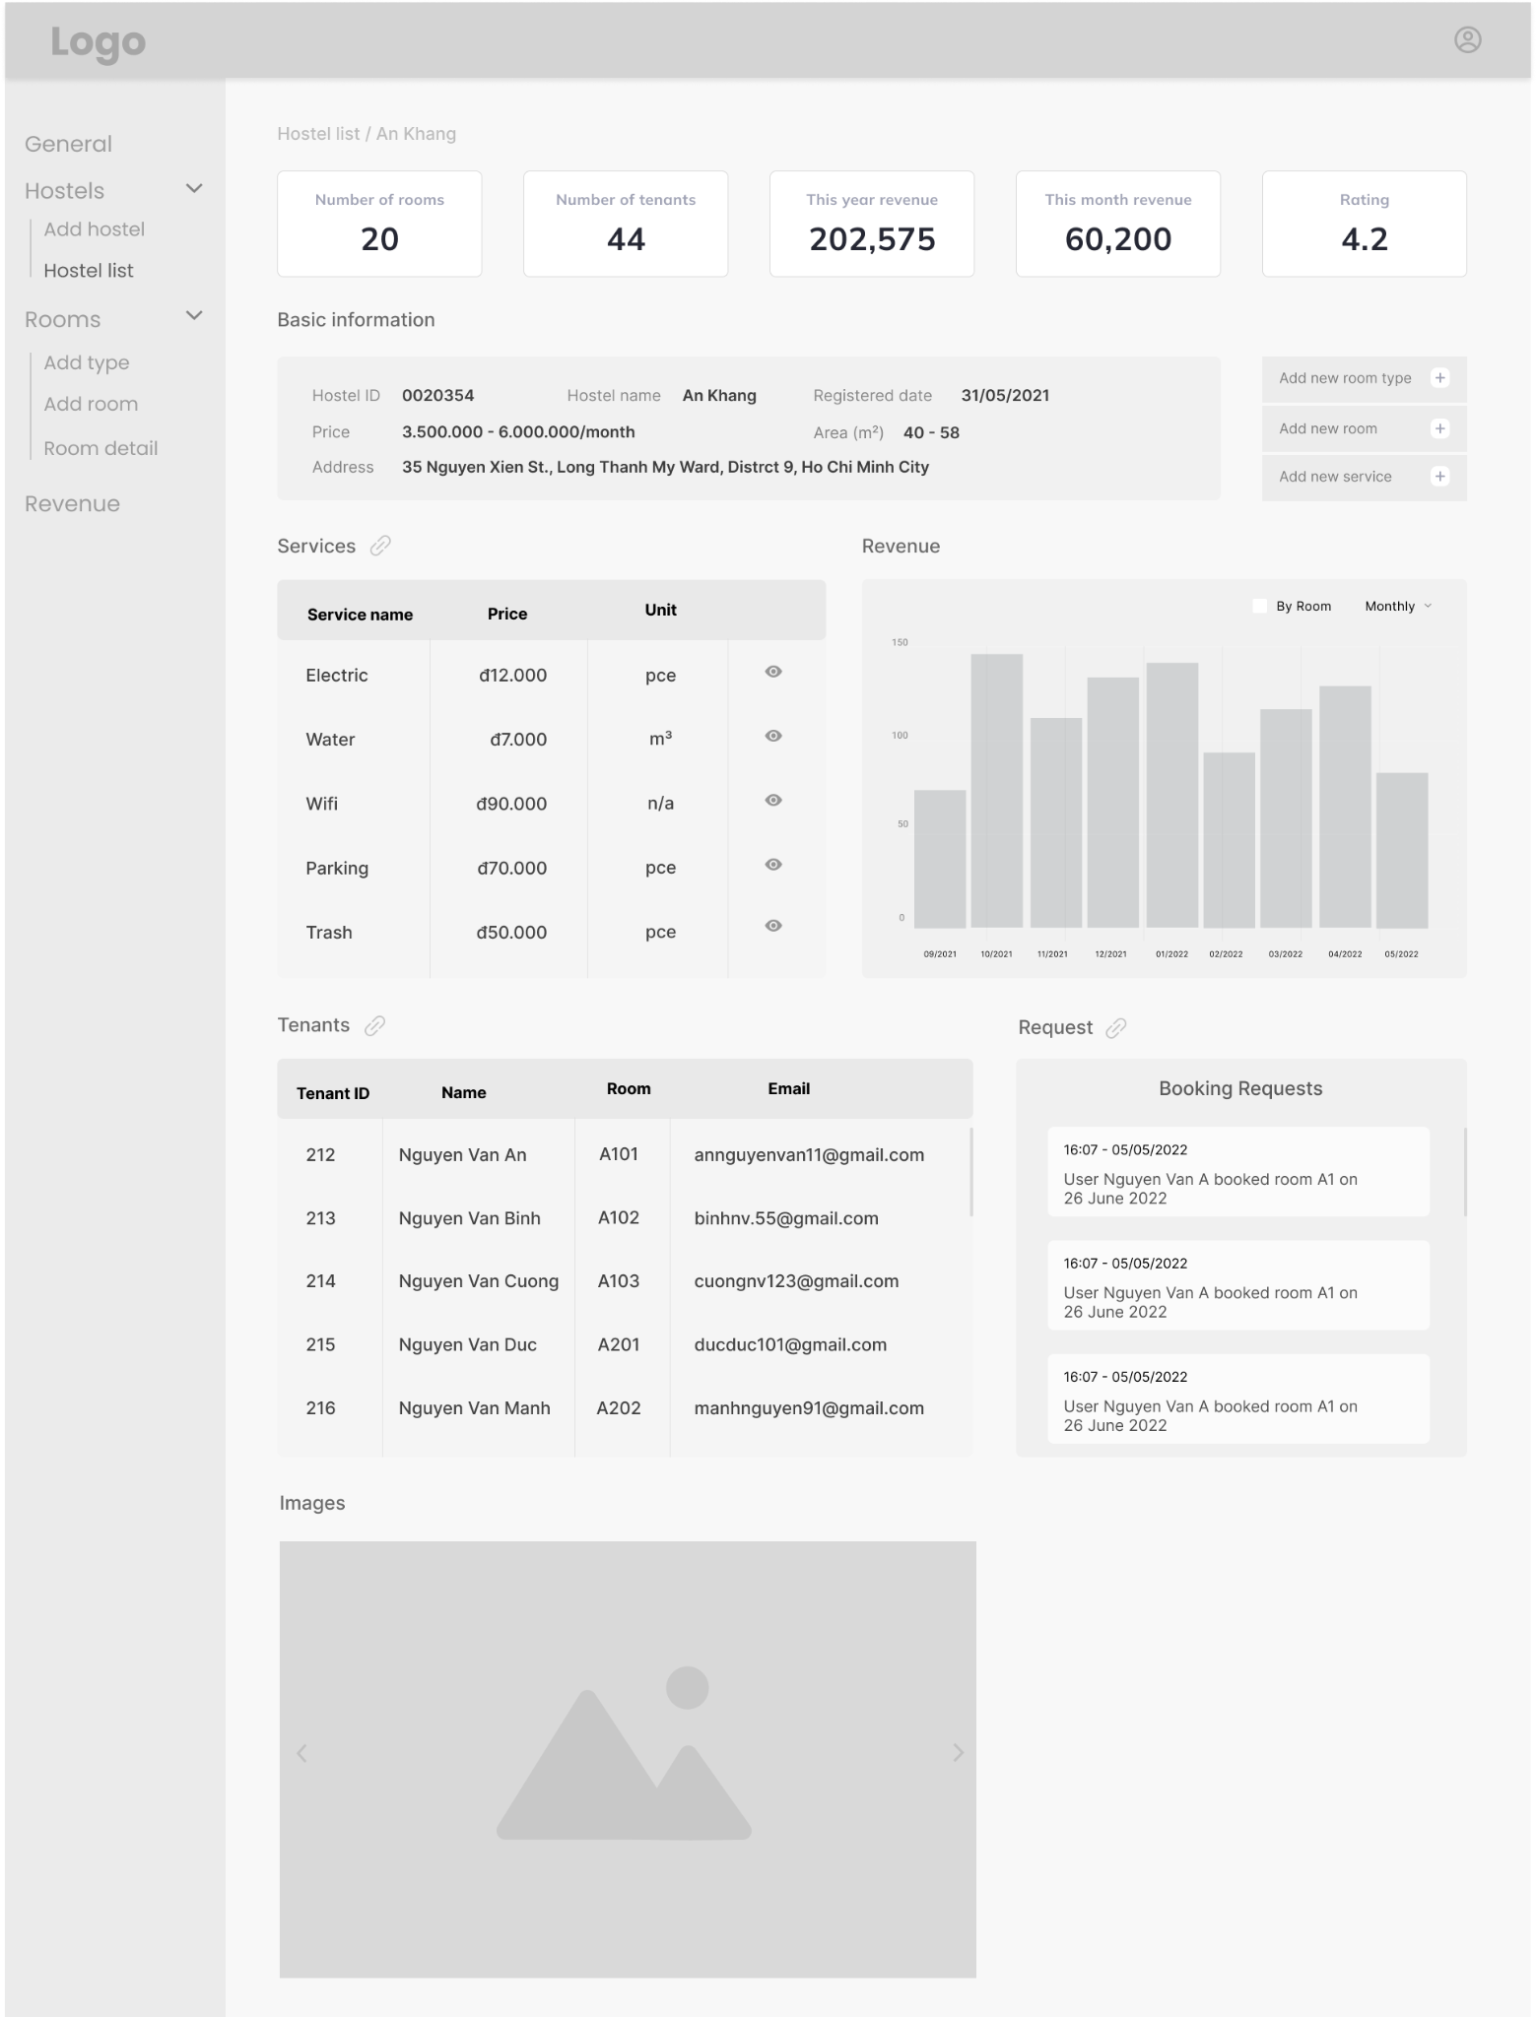

* Details: Landlords can view their hostels’ detailed information such as address, current residents, statistical charts.

### Edit hostel’s detail

* Trigger: When the landlords click on edit hostel button on the hostel list
* Description: Landlords can edit their hostels’ information
* Layout:

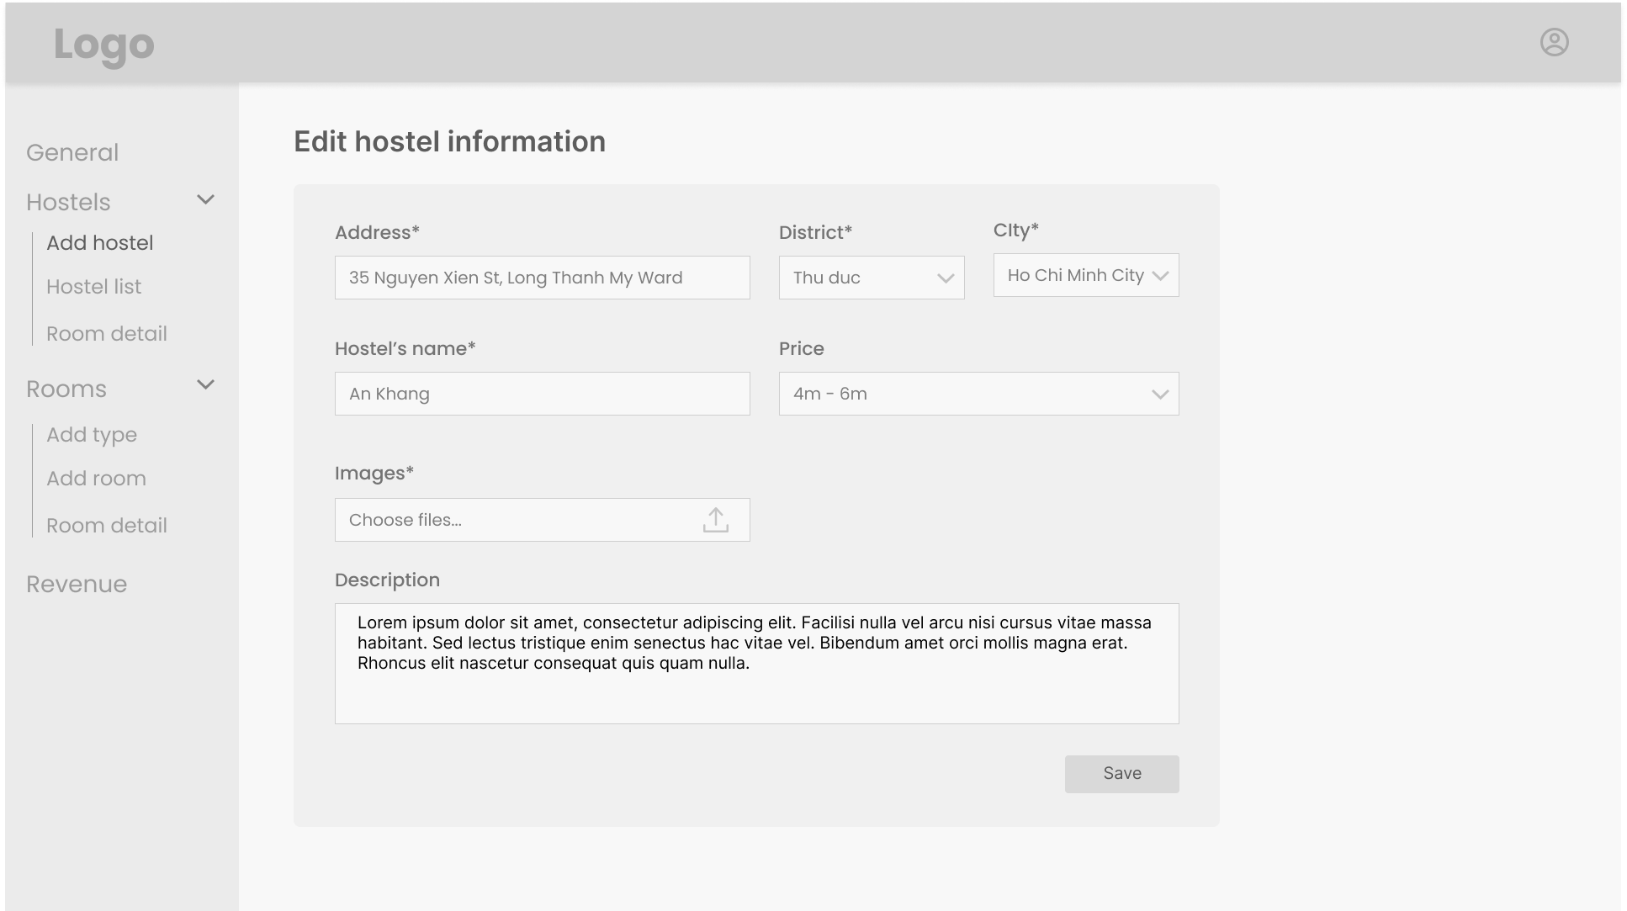

* Details: Landlords can change some information of their hostel such as address, services, images, hostel name.

### Activate/deactivate a hostel

* Trigger: When the landlords click on activate/deactivate button on the hostel list
* Description: Landlords can activate/deactivate their hostel
* Layout:

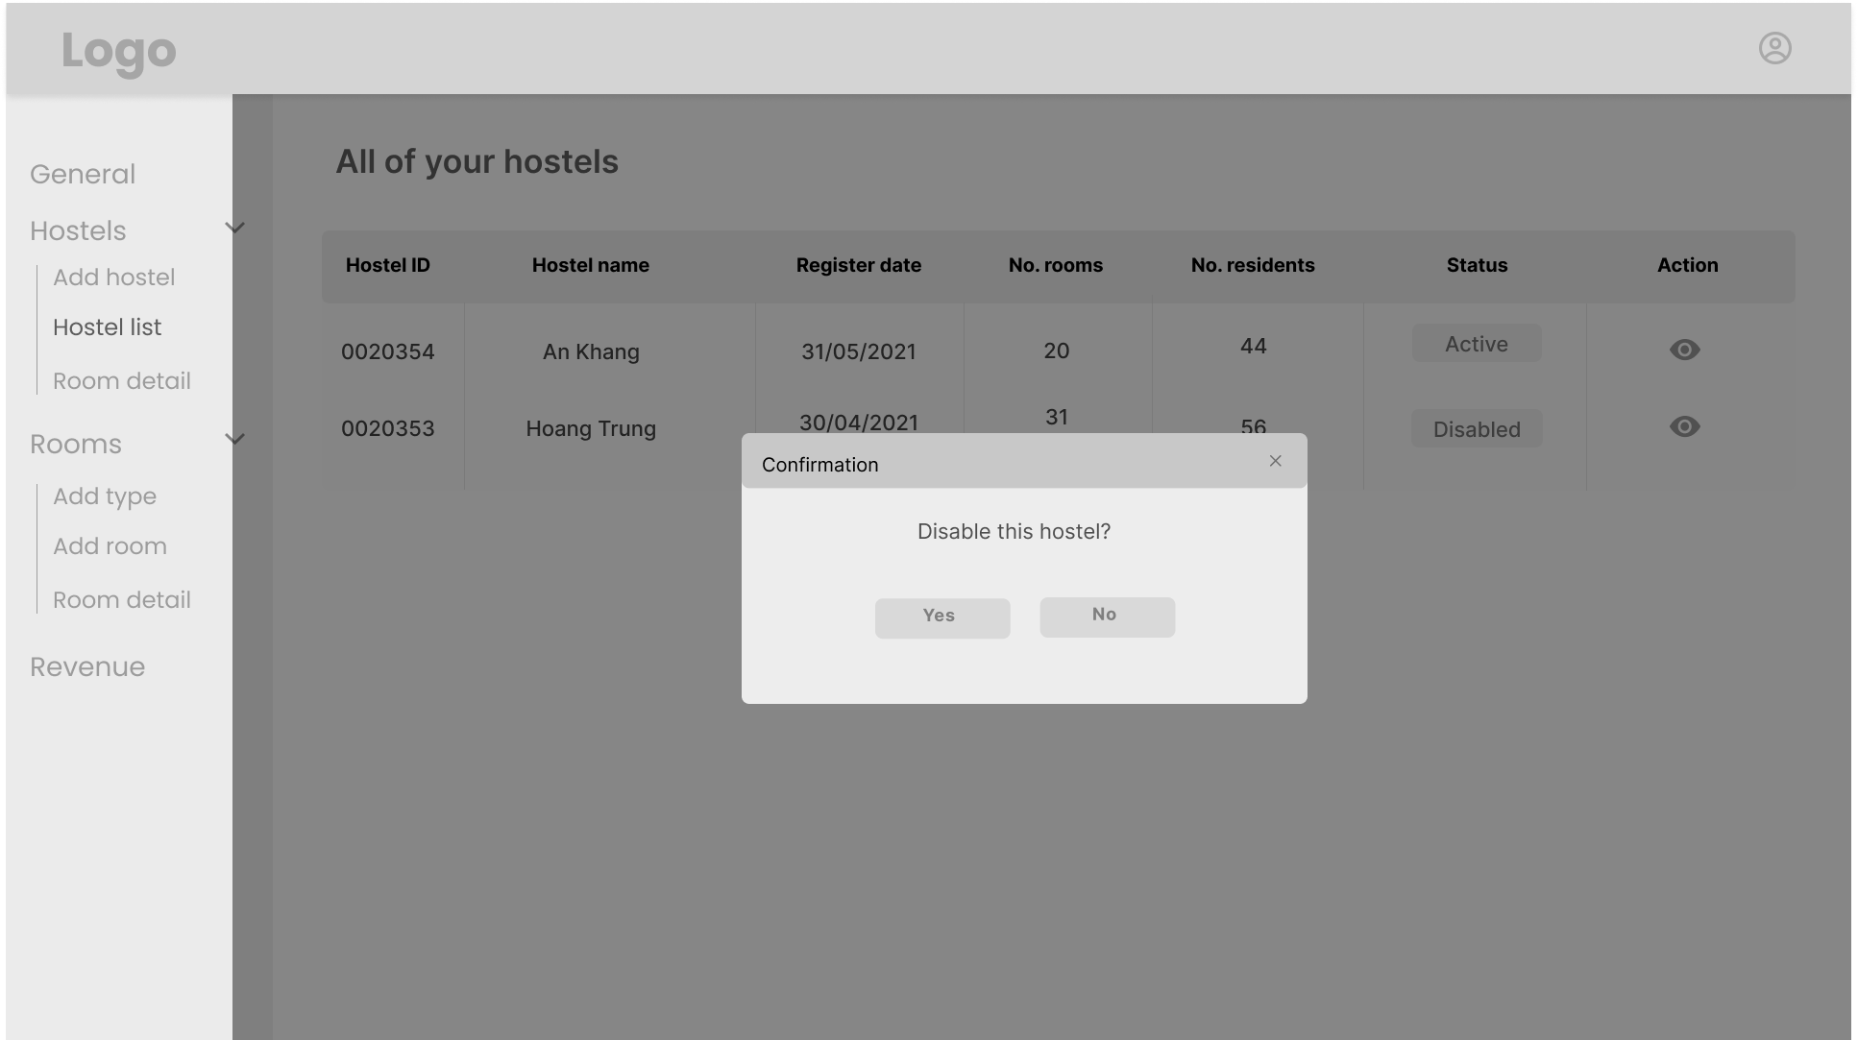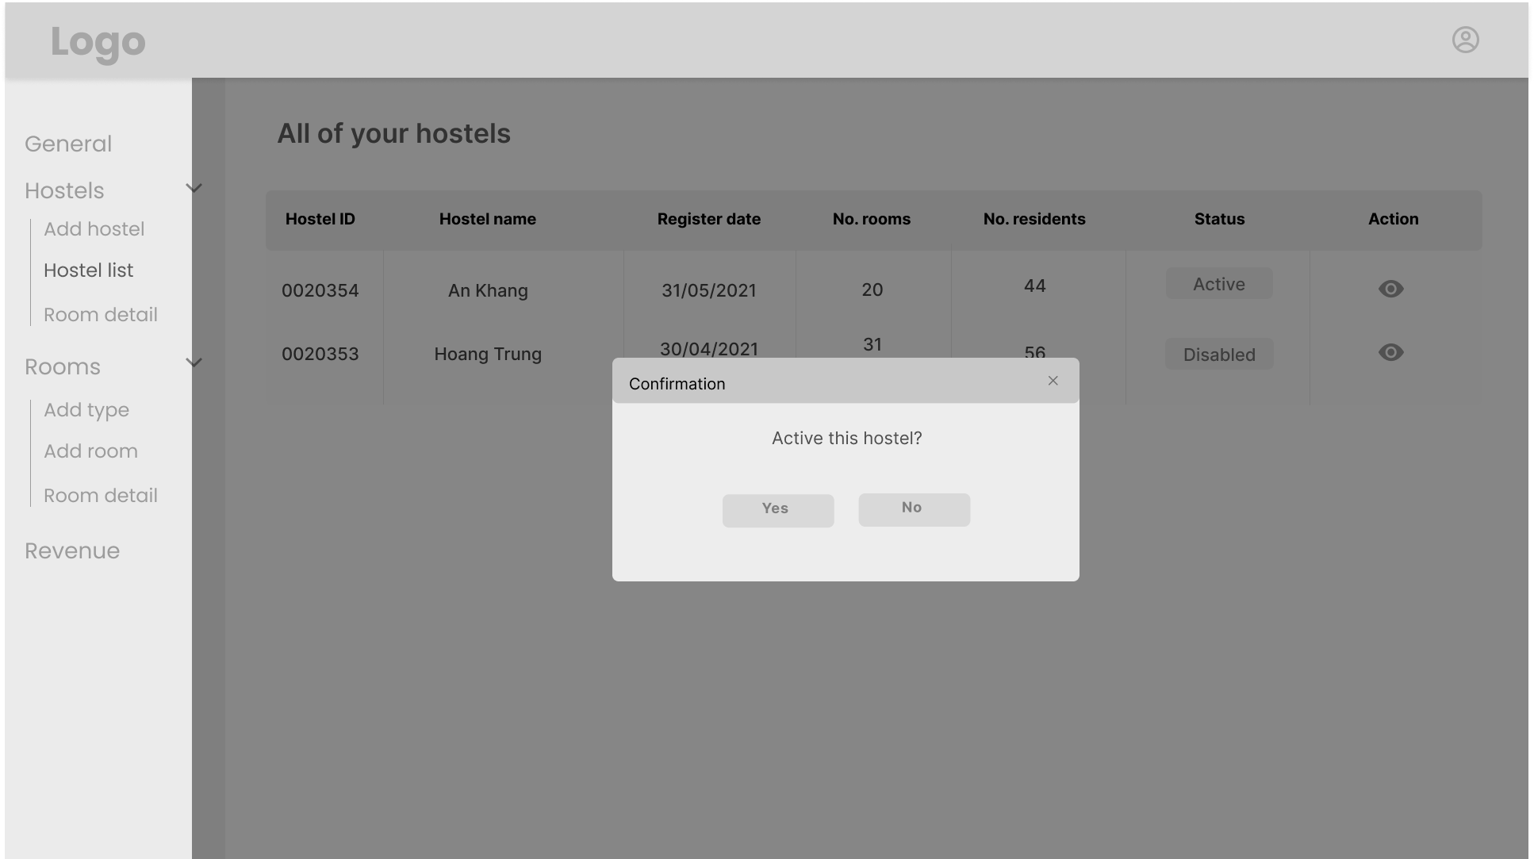

* Details: Landlords can choose to deactivate their hostel if they don’t want to use it for renting anymore, or re-activate one if they’re willing to use it for renting again

## Room management for landlord

### View room type list

* Trigger: When the landlords click on add type in landlord dashboard
* Description: Landlords can view their room type list
* Layout:

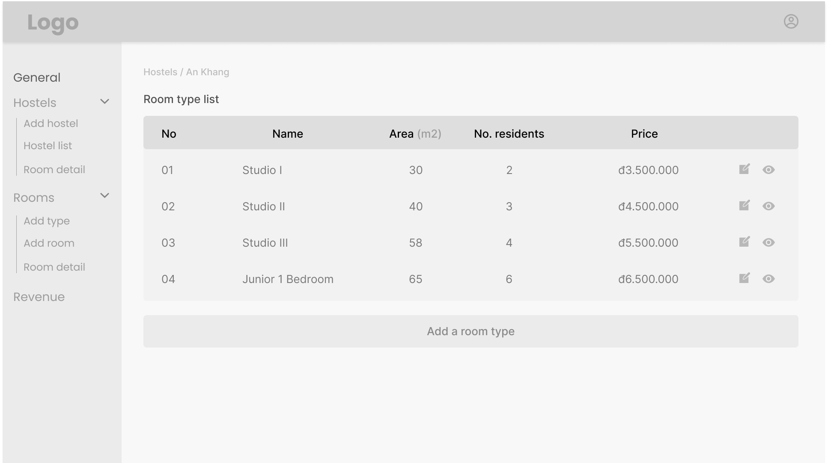

* Details: Landlords can view their room type information such as number of, name, area, number of residents and price

### Add room type

* Trigger: When the landlords click on add new room type in view room type list
* Description: Landlords can add a new room type
* Layout:

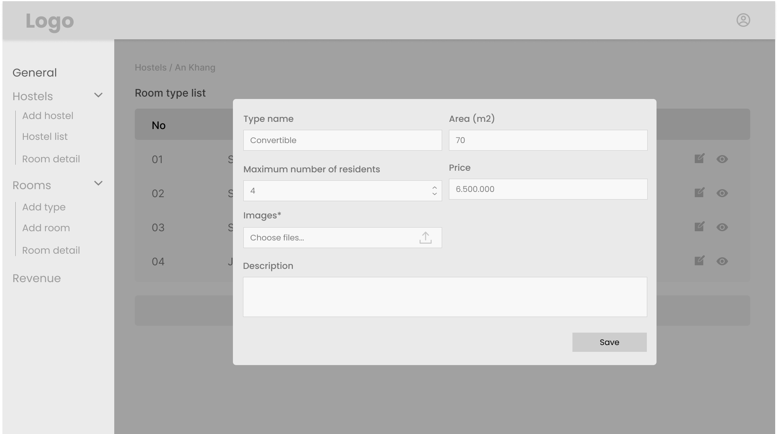

* Details: Landlord must provide information about type name, area, maximum number of residents, advertised price, images and description to add a room type

### Edit room type

* Trigger: When the landlords click on edit room type in view room type list
* Description: Landlords can edit a room type
* Layout:

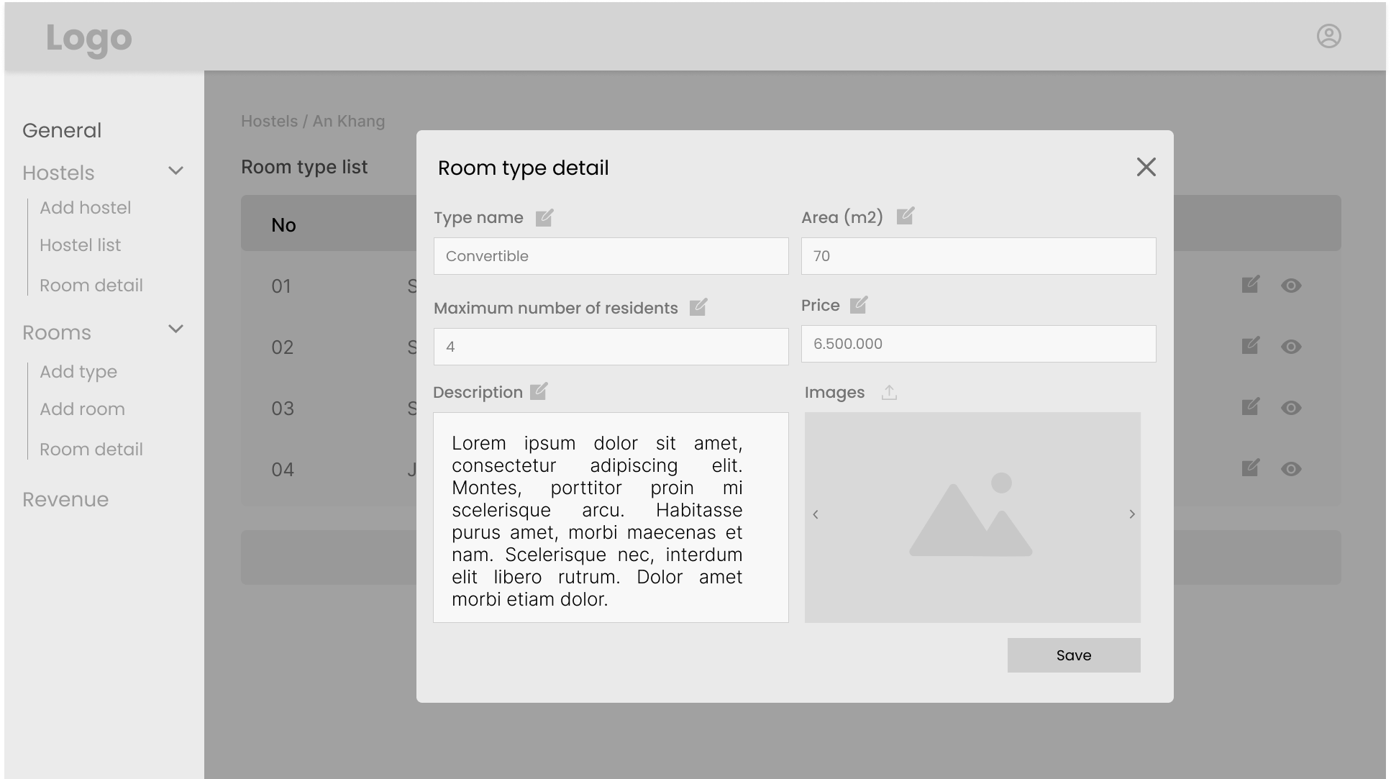

* Details: Landlords can view room type’s information and choose to edit them as they pleased. After editing, they can click the save button to save room type changed information

### View room list with paging

* Trigger: When a landlords clicks on room list on the page of a hostel he owns
* Description: A landlord can view the list of rooms in one of his hostels.
* Layout:

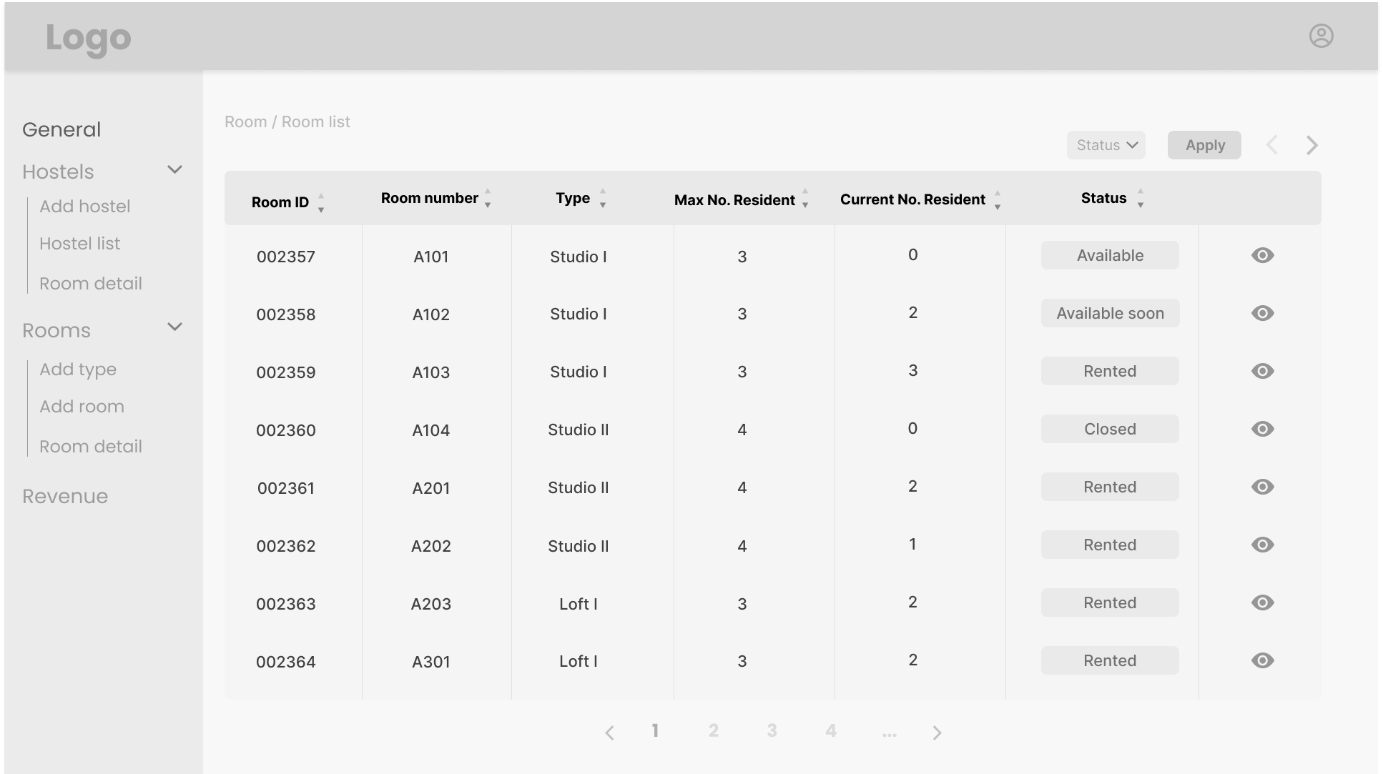

* Details: Rooms of the hostel are displayed with a maximum number of 8 rooms on one page. The landlord can navigate through pages using links at the bottom of the page.

### Add a room

* Trigger: When a landlords clicks on a button on the page of a hostel he owns
* Description: A landlord can add one or multiple rooms to a hostel.
* Layout:

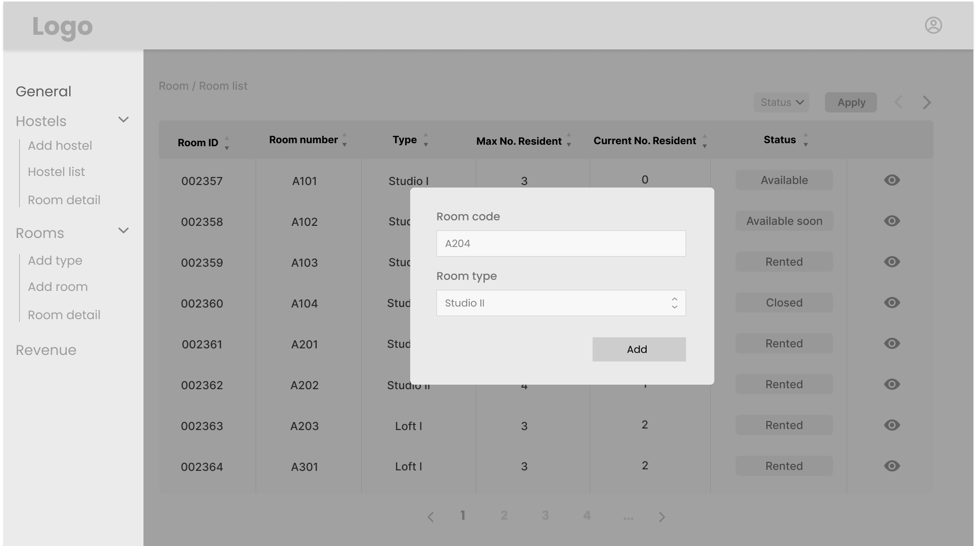

* Details: A landlord enters information about a room, which includes the area, the utilities, description, etc. He can choose to add multiple rooms with the same features.

### Remove a room

+ Trigger: When landlords change status of the room

+ Description: Landlords change status of a room to closed state

+ Layout: None

+ Details: When landlords click change status of a room, it will switch state from open, closed or near open

### View room’s detail

* Trigger: When the landlords clicks on a link to a specific room on the room list
* Description: A landlord can view the details of a room in a hostel he owns
* Layout:

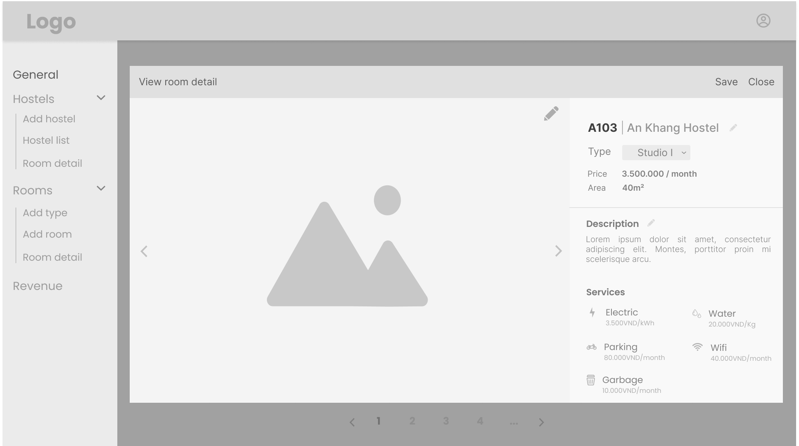

* Details: Basic information about the room is displayed, including area, utilities and price and usage status (rented or not rented). If the room is currently rented, information about the tenant as well as the current residents will be displayed.

### Edit room’s detail

* Trigger: When the landlords click on a button to edit the information of the room
* Description: A landlord can edit the details of a room in a hostel he owns
* Layout:



* Details: Various fields related to the information of the room are displayed in textboxes. These include area, utilities, current tenant, current residents etc. The landlord can modify these fields and click “Save” to save the new information to the database.

### View service list

* Trigger: When the landlords click on add services in the sub-menu in the navigation bar
* Description: A landlord can view the service list of a hostel
* Layout:

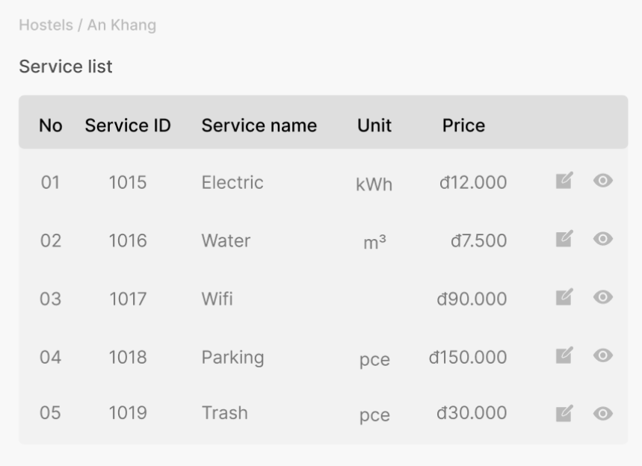

* Details: He/she can view the service information such as service name, month applied, service fee, unit.

### View service history

* Trigger: When the landlords click on view service history
* Description: A landlord can view the service history list of a hostel
* Layout:

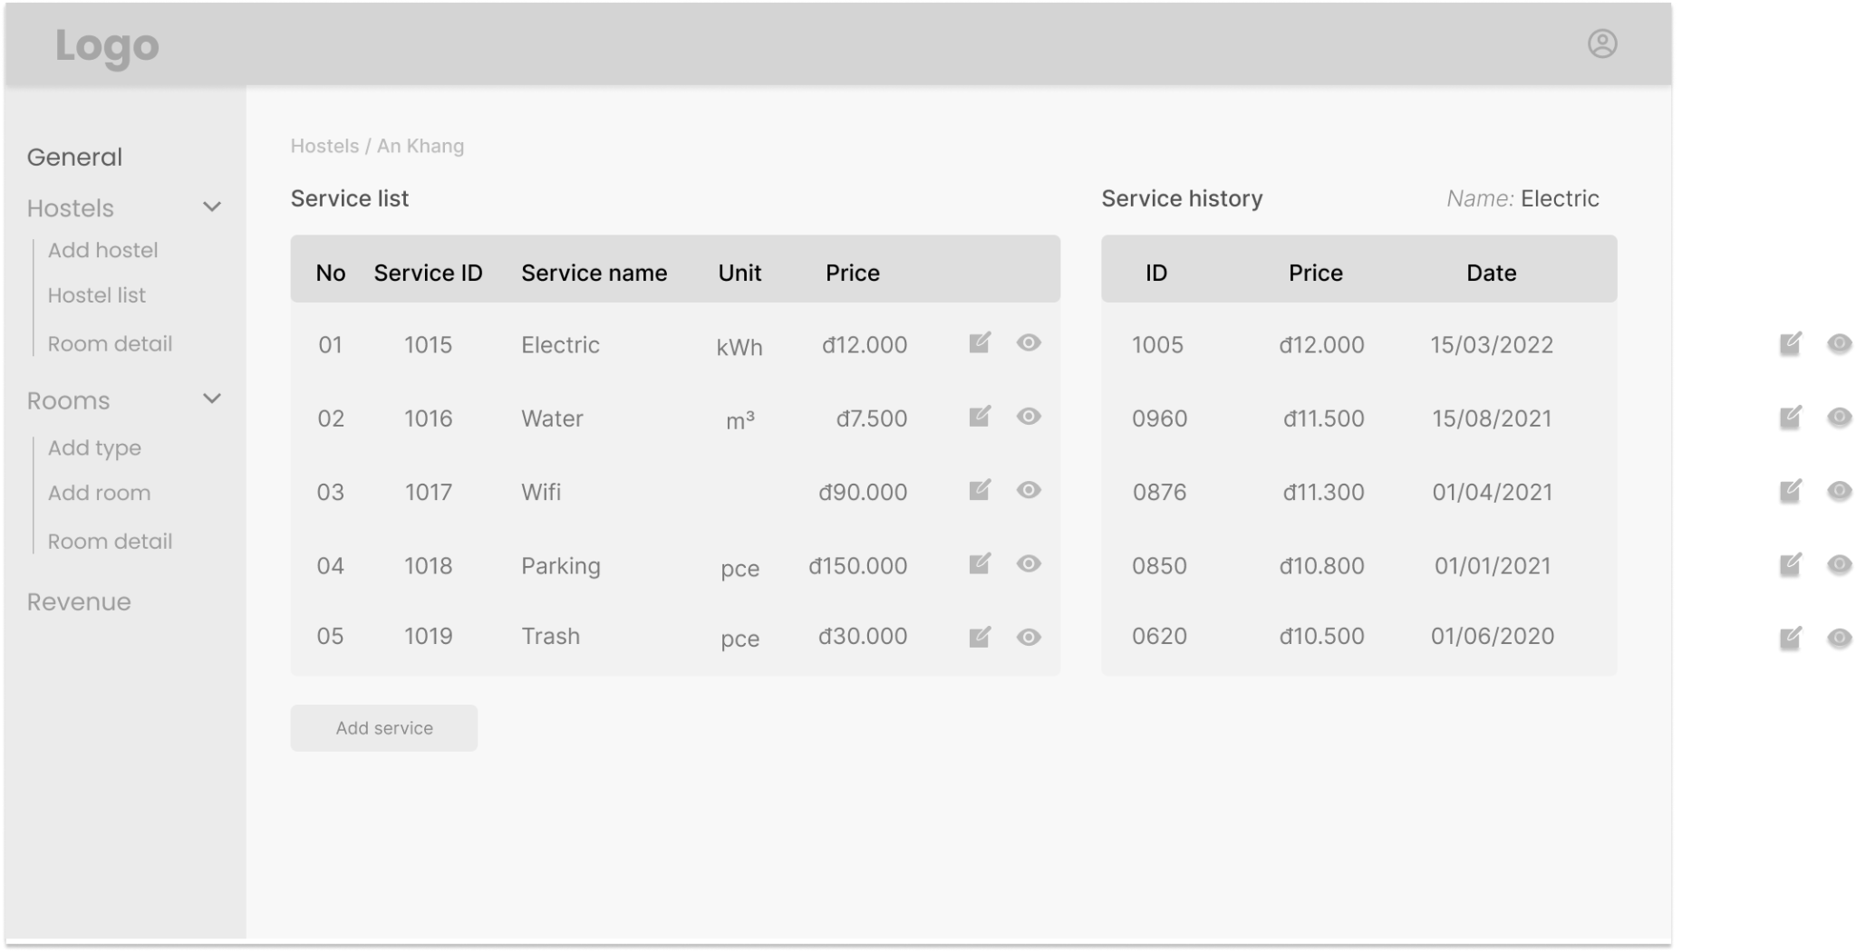

* Details: He/she can view the service history information such as service name, unit, price, date of service

### Add service

* Trigger: When the landlords click on a button to edit the utilities on a page of a room
* Description: A landlord can add a utility to a room in a hostel he owns
* Layout:

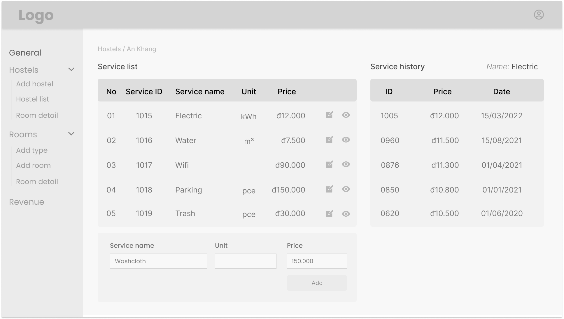

* Details: A landlord enters the name of the new service, its price and other related details. He then clicks “Save” to save the data.

### Edit service

* Trigger: When the landlords click on a button to edit the utilities on a page of a room
* Description: A landlord can add a utility to a room in a hostel he owns
* Layout:

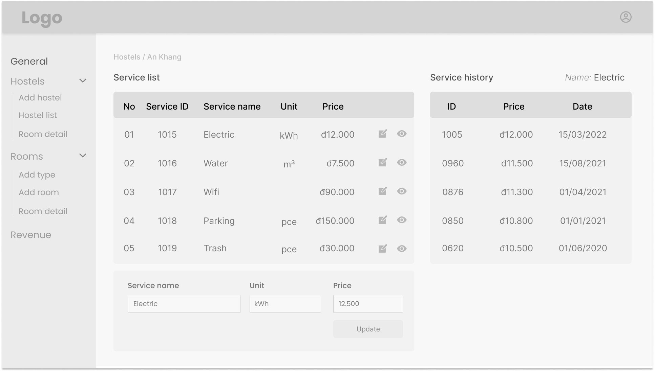

* Details: A landlord enters the name of the new service, its price and other related details. He then clicks “Save” to save the new utility to the room.

## 12. Room resident management for landlord

### View room resident list with paging

* Trigger: When the landlords click on the room resident list in room detail
* Description: A landlord can view the list of room residents in a room
* Details: The landlord can view the name, date of birth, phone in a room
* Layout:

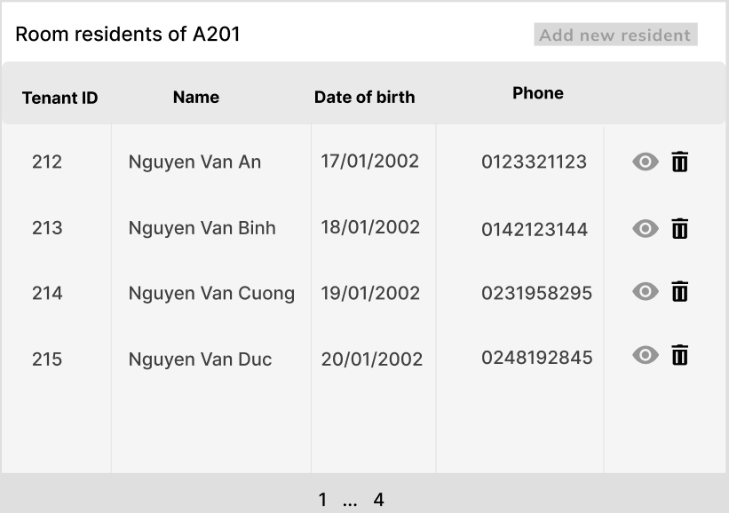

### Approve a rental request

* Trigger: A tenant has sent a request to rent a room that a landlord owns.
* Description: A landlord can view the request of a tenant who wants to rent a room that the landlord owns.
* Details: The request will come with information for the landlord to contact the tenant who the request comes from.
* Layout:

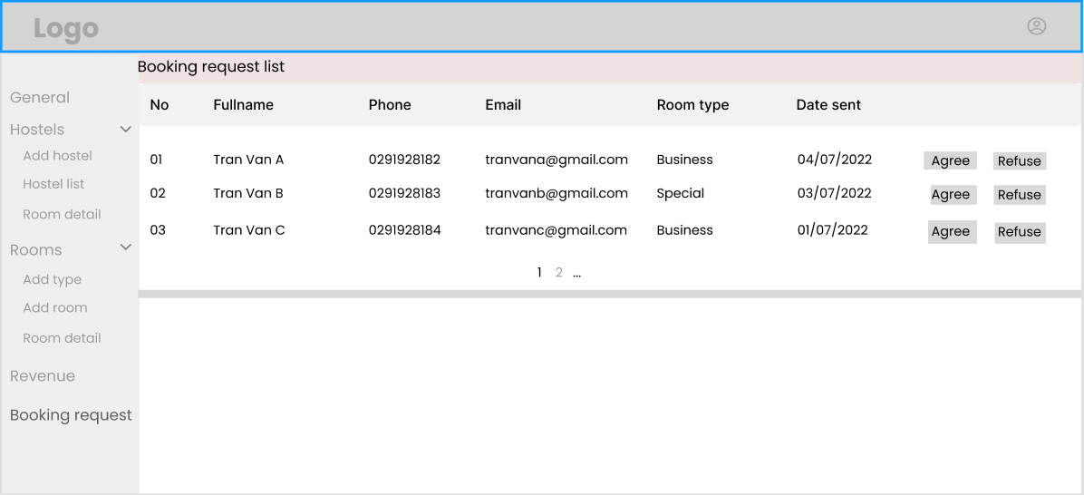

### Remove a room resident

* Trigger: When landlords click ‘remove room resident’ in room resident list
* Description: A landlord can remove a room resident
* Details: Landlord can remove a room resident. The system will ask twice if landlord is sure about his/her decision
* Layout:



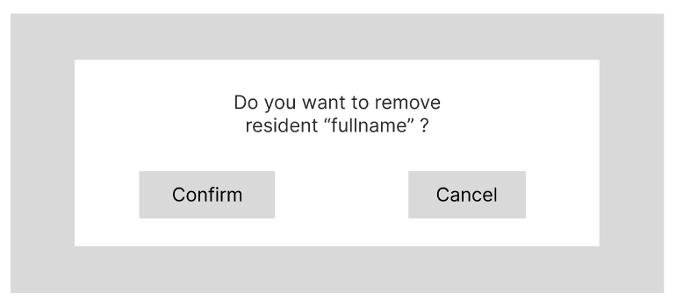

### View room resident’s detail

* Trigger: When landlords click on the room resident in room resident list
* Description: A landlord can view room resident’s detailed information
* Details: Landlords can view room resident’s detailed information such as full name, phone number, date of birth, …
* Layout:

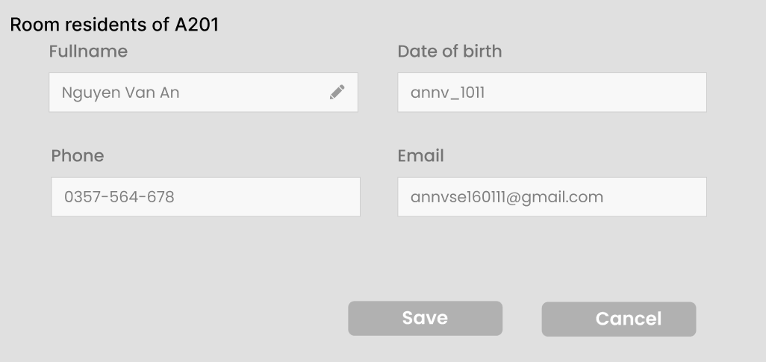

### Edit room resident’s information

* Trigger: When landlords click edit room resident information’ in room resident list
* Description: A landlord can edit room resident’s information
* Details: A landlord can edit room resident’s information such as full name, date of birth, phone. This function won’t affect the tenant's user profile, as it will be saved as room residents' profile.
* Layout:



### Send announcement to room residents

* Trigger: When the landlords click the button to create a message on the announcements page.
* Description: A landlord can create a message and choose a room resident who the announcement is for or choose all room residents in a hostel.
* Details: The landlord fills in the content of the announcement, choosing who to send it to by selecting on the list of room residents, and clicks “Send”.
* Layout:

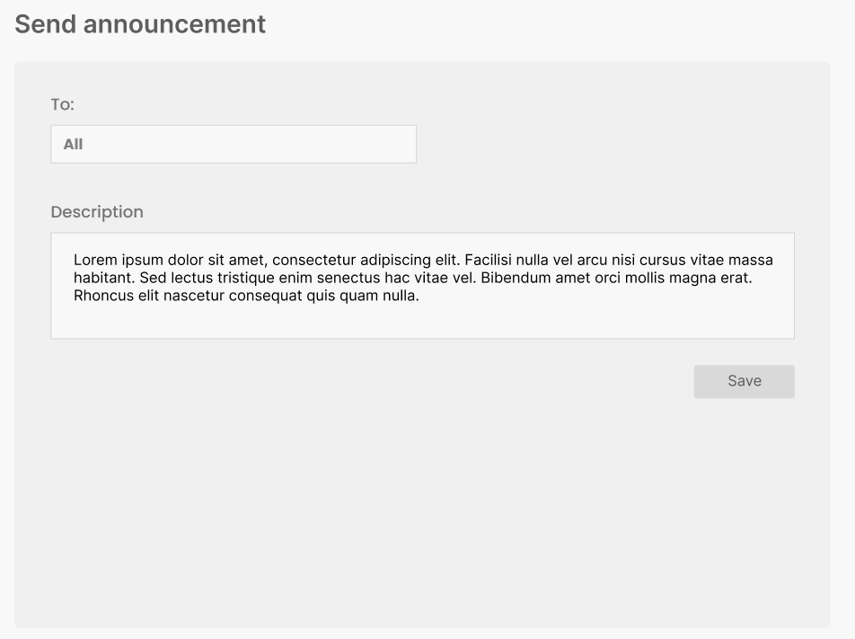

### Post payment invoice

* Trigger: When the landlords click the button to post an invoice on the invoice creation page.
* Description: A landlord can create an invoice for a room
* Layout:
* Details: The landlord fills in the content of the announcement, choosing who to send it to by selecting on the list of rooms to choose the one who signed the contract, and clicks “Send”.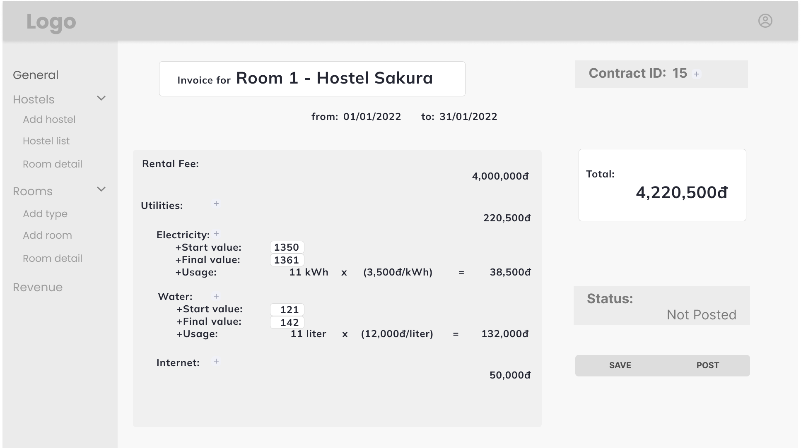

## 15. Revenue management for landlords

### View revenue statistics of a specific hostel

* Trigger: When a landlord clicks a link to view the finance statistics on the page of a specific hostel
* Description: A landlord can view the statistics of revenue of a hostel he owns.
* Details: Revenue of a hostel is displayed on some kinds of graph. The landlord can choose to display the revenue in different time windows.
* Layout:

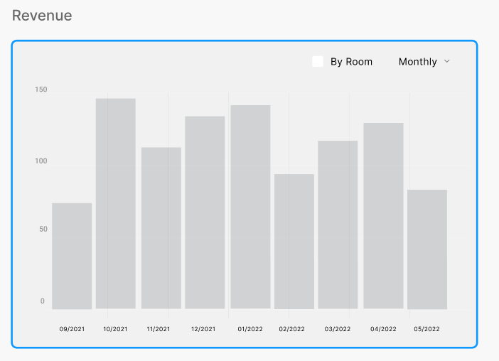

### Export to Excel file

* Trigger: A landlord clicks on a link to export data to an excel file on the revenue page of a hostel
* Description: statistics of the revenue of a hostel can be exported into an excel file.
* Details: The landlord chooses the kind of information to be exported, as well as the destination folder and the name of the excel file. He then clicks on the export button and confirms.
* Layout: None

## 16. Admin features

### View landlord list with paging

* Trigger: When an admin clicks on landlord list on the admin dashboard
* Description: An admin can view the list of landlords who have had hostels for rent up to the present.
* Layout:

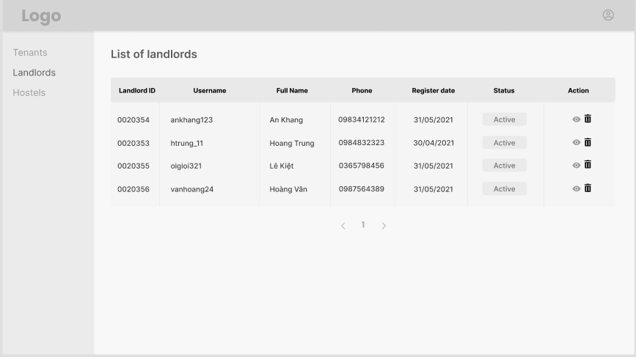

* Details: A maximum number of 10 landlords will be displayed on one page. The admin can navigate through the list using the pages link at the bottom of each page. The information of each landlord displayed includes the landlord’s name, the landlord’s ID, etc.. Further information about a landlord can be found by clicking on a link next to the name.

### Edit landlord’s information

* Trigger: When an admin clicks on ‘Edit’ button connect to a landlord on landlord management of admin dashboard
* Description: Admin can edit landlord’s information
* Details: Various fields of details of the landlord are displayed on the screen. The admin can modify the contents of the fields and clicks on ‘Save’. The system asks the admin to verify before updating the data. The admin can cancel the process at any time by clicking the ‘Cancel’ button. This will send a notification to the landlord’s account.
* Layout:

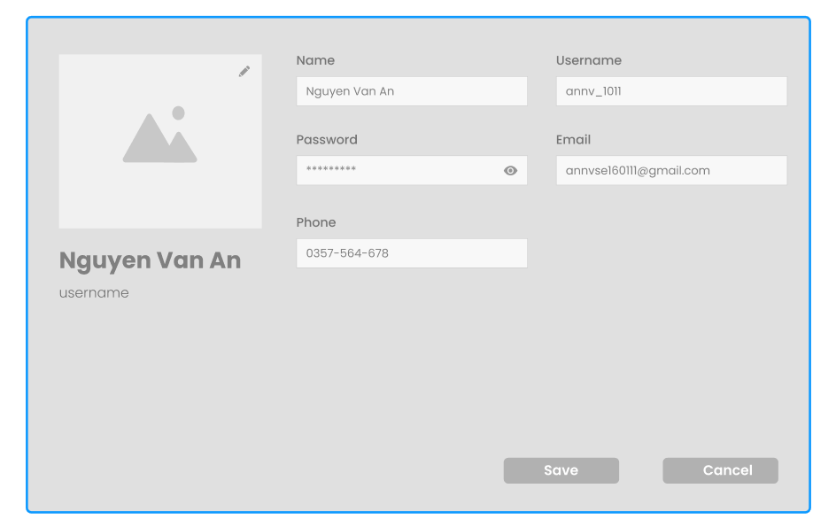

### Activate/Deactivate a landlord account

* Trigger: When an admin clicks ‘activate/deactivate’ in landlord management
* Description: Admin can activate/deactivate a landlord’s account
* Details: If the landlord is currently active, the button shows ‘Activate’, and vice versa. Admin can change the status of an account by clicking on the ‘Active/Inactive’ in status column. The system asks the admin to verify his decision when he clicks on the button. After the admin clicks ‘Yes’, the system updates the status of the landlord. The admin can cancel the process by clicking ‘Cancel’.
* Layout:

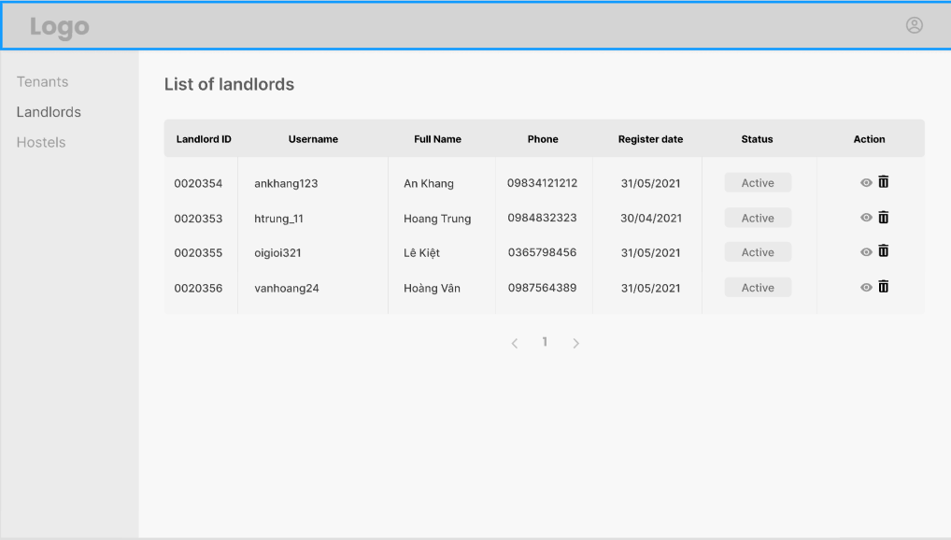

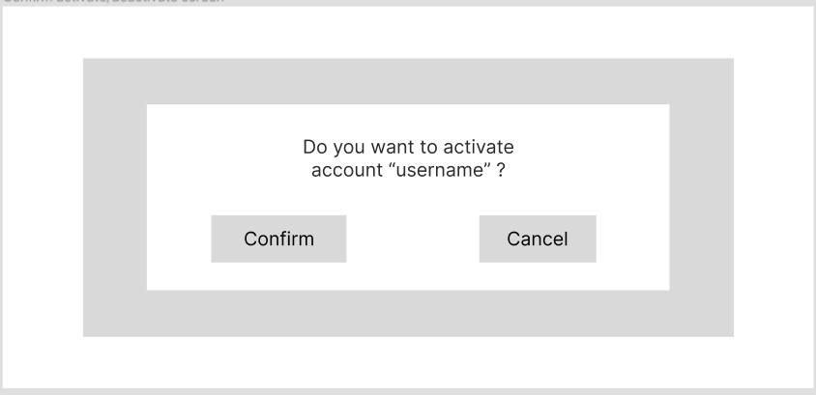

### View hostel list with paging

* Trigger: When an admin clicks on hostel list on the admin dashboard
* Description: An admin can view the list of hostels which have been listed for rent in the system up until the present.
* Layout:

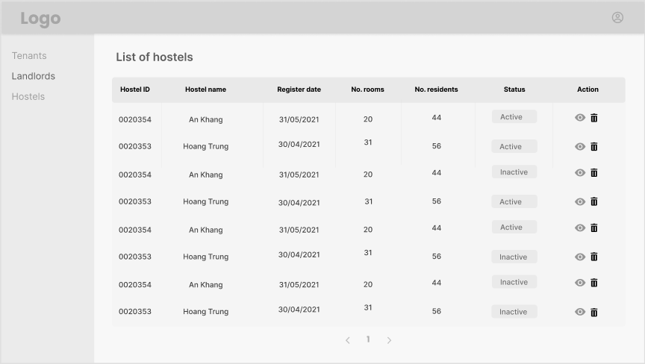

* Details: A maximum number of 10 hostels will be displayed on one page. The admin can navigate through the list using the pages link at the bottom of each page.The information of each hostel displayed includes the name and the ID of the hostel, etc. Further information about each hostel can be found by clicking on a link next to its name.

### Edit hostel’s information

* Trigger: When an admin clicks on Edit’ button connect to a hostel on hostel management of admin dashboard
* Description: An admin can edit the details of a hostel stored in the system.
* Layout:

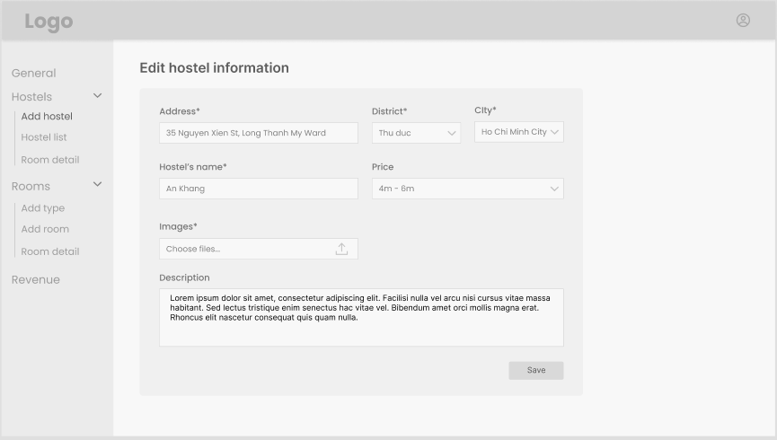

* Details: Various fields of details of the hostel are displayed on the screen. The admin can modify the contents of the fields and clicks on ‘Save’. The system asks the admin to verify before updating the data. The admin can cancel the process at any time by clicking the ‘Cancel’ button.

### Activate/Deactivate a hostel

* Trigger: When an admin clicks on ‘Activate’/’Deactivate’ button on hostel management of admin dashboard
* Description: An admin activates or deactivates the status of a hostel in the system.
* Details: If the landlord is currently active, the button shows ‘Activate’, and vice versa. Admin can change the status of an account by clicking on the ‘Active/Inactive’ in status column. The system asks the admin to verify his decision when he clicks on the button. After the admin clicks ‘Yes’, the system updates the status of the landlord. The admin can cancel the process by clicking ‘Cancel’
* Layout:

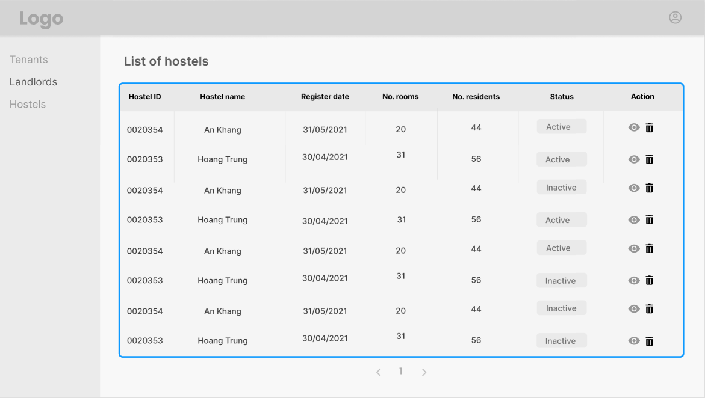

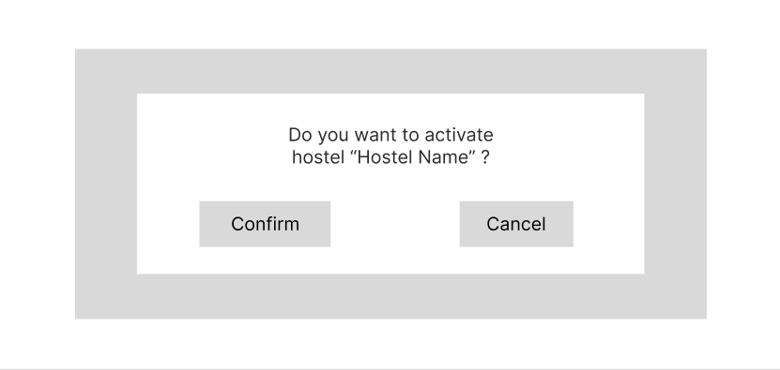

### View tenant list with paging

* Trigger: When an admin clicks on tenant list on the admin dashboard
* Description: An admin can view the list of tenants which have had contracts stored in the system up until the present.
* Layout:

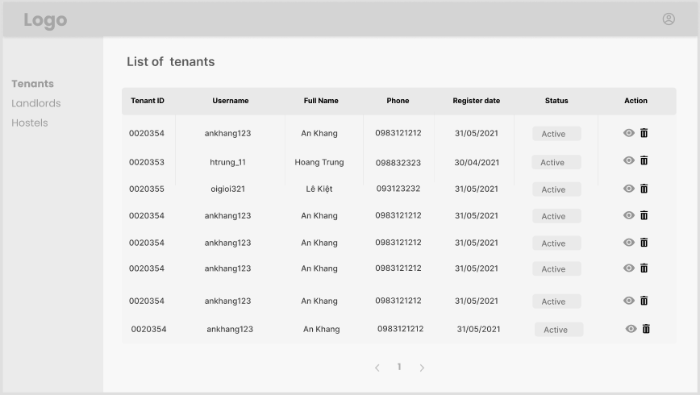

* Details: A maximum number of 10 tenants will be displayed on one page. The admin can navigate through the list using the pages link at the bottom of each page. The information of each tenant displayed includes the name and the ID of the tenant, etc. Further information about each tenant can be found by clicking on a link next to the name.

### Edit tenant’s information

* Trigger: When an admin clicks on ‘Edit’ button connect to a tenant on tenant management of admin dashboard
* Description: An admin can edit the details of a tenant stored in the system.
* Details: Various fields of details of the tenant are displayed on the screen. The admin can modify the contents of the fields and clicks on ‘Save’. The system asks the admin to verify before updating the data. The admin can cancel the process at any time by clicking the ‘Cancel’ button.
* Layout:



### Activate/Deactivate a tenant account

* Trigger: When an admin clicks on ‘Active/Inactive’ button on tenant management of admin dashboard
* Description: An admin activates or deactivates the status of a tenant in the system.
* Details: If the landlord is currently active, the button shows ‘Activate’, and vice versa. Admin can change the status of an account by clicking on the ‘Active/Inactive’ in status column. The system asks the admin to verify his decision when he clicks on the button. After the admin clicks ‘Yes’, the system updates the status of the landlord. The admin can cancel the process by clicking ‘Cancel’.
* Layout:

